**PES UNIVERSITY**

**Department of Computer Science & Engineering**



DBMS - UE20CS301

Mini Project

Inventory Management System

## Submitted to: Submitted By:

Dr. Geetha D Name: Vishwa Mehul Mehta

Associate Professor SRN: PES2UG20CS389

Semester: V

Section: F

# Table of Contents

|  |  |  |
| --- | --- | --- |
| **Sl.No** | **Title** | **Page No** |
| 1. | Short Description and Scope of the Project | 3 |
| 2. | Entity Relationship Diagram | 4 |
| 3. | Relational Schema | 5 |
| 4. | DDL Statements-Building the  Database | 6 |
| 5. | Populating the Database | 9 |
| 6. | Join Queries | 13 |
| 7. | Attribute Functions | 15 |
| 8. | Set Operations | 17 |
| 9. | Functions and Procedures | 20 |
| 10. | Triggers and Cursors | 24 |
| 11. | Frontend Application | 30 |
| 12. | Conclusion | 58 |
| 13. | References | 59 |

**1. Short Description and Scope of the Project**

ListAll is a web application that monitors and manages the goods and products in stock. The application uses a database and database operations to store information about the retailers and their respective products that are sold. It displays a list of all products and their quantities, customers who bought the items and their details along with invoice for each product purchased. It allows for performing CRUD operations for all the details. ListAll uses a simple frontend using Python based Streamlit and MySQL for the backend. The application aims to find profit/loss and generate it for a particular month or year as a future application.

**2. ER Diagram**

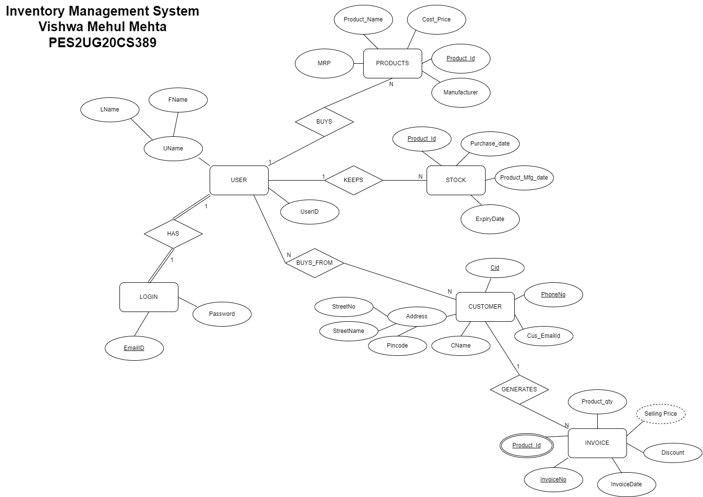

**3. Relational Schema**

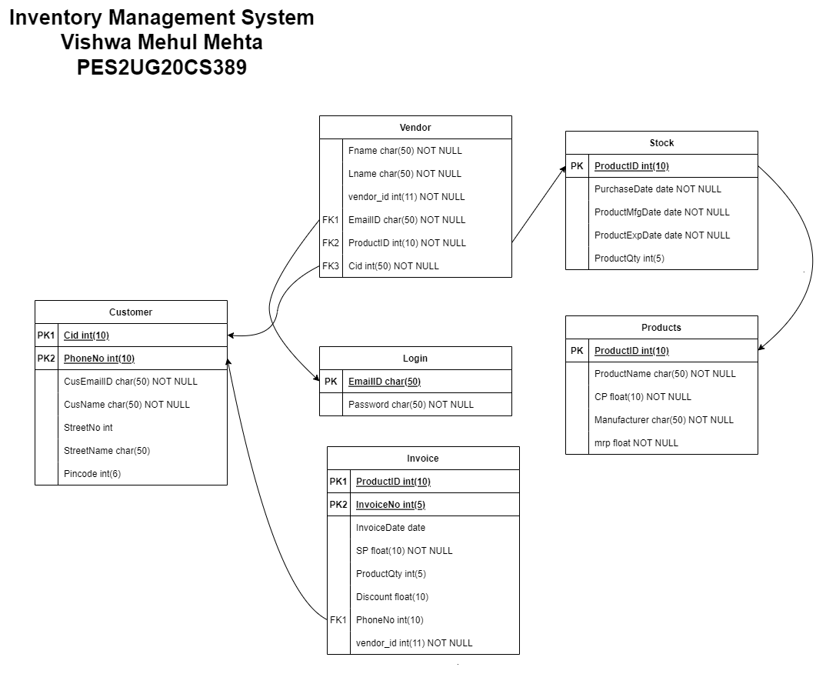

**4. DDL statements - Building the database**

-- Table structure for table `customer`

--

CREATE TABLE IF NOT EXISTS `customer` (

  `cust_id` int(10) NOT NULL,

  `phone_no` bigint(10) NOT NULL,

  `cust_email_id` varchar(50) NOT NULL,

  `cust_name` varchar(50) NOT NULL,

  `str_no` int(11) DEFAULT NULL,

  `str_name` varchar(50) DEFAULT NULL,

  `pincode` int(6) DEFAULT NULL,

  PRIMARY KEY (`cust_id`,`phone_no`)

) ENGINE=MyISAM DEFAULT CHARSET=utf8;

-- Table structure for table `invoice`

--

CREATE TABLE IF NOT EXISTS `invoice` (

  `prod_id` int(10) NOT NULL,

  `invoice_no` int(10) NOT NULL,

  `invoice_date` date NOT NULL,

  `selling_price` float NOT NULL,

  `prod_qty` int(11) DEFAULT '0',

  `discount` float DEFAULT NULL,

  `phone_no` bigint(10) DEFAULT NULL,

  `vendor_id` int(11) NOT NULL,

  PRIMARY KEY (`prod_id`,`invoice_no`),

  KEY `phone_no` (`phone_no`)

) ENGINE=MyISAM DEFAULT CHARSET=utf8;

-- Table structure for table `login`

--

CREATE TABLE IF NOT EXISTS `login` (

  `email_id` varchar(50) NOT NULL,

  `pass` varchar(50) NOT NULL,

  PRIMARY KEY (`email_id`)

) ENGINE=MyISAM DEFAULT CHARSET=utf8;

-- Table structure for table `product`

--

CREATE TABLE IF NOT EXISTS `product` (

  `product_id` int(10) NOT NULL,

  `product_name` varchar(50) NOT NULL,

  `cost_price` float NOT NULL,

  `manufacturer` varchar(50) NOT NULL,

  `mrp` float NOT NULL,

  PRIMARY KEY (`product_id`)

) ENGINE=MyISAM DEFAULT CHARSET=utf8;

-- Table structure for table `stock`

--

CREATE TABLE IF NOT EXISTS `stock` (

  `pid` int(10) NOT NULL,

  `purchase_date` date NOT NULL,

  `mfg_date` date NOT NULL,

  `pqty` int(11) DEFAULT '0',

  PRIMARY KEY (`pid`)

) ENGINE=MyISAM DEFAULT CHARSET=utf8;

-- Table structure for table `vendor`

--

CREATE TABLE IF NOT EXISTS `vendor` (

  `fname` varchar(50) NOT NULL,

  `lname` varchar(50) NOT NULL,

  `vendor_id` int(11) NOT NULL,

  `email_id` varchar(50) NOT NULL,

  `product_id` int(10) DEFAULT NULL,

  `cust_id` int(10) DEFAULT NULL,

  KEY `email_id` (`email_id`),

  KEY `cust_id` (`cust_id`),

  KEY `product_id` (`product_id`)

) ENGINE=MyISAM DEFAULT CHARSET=utf8;

**5. Populating the Database**

-- Dumping data for table `customer`

--

INSERT INTO `customer` (`cust_id`, `phone_no`, `cust_email_id`, `cust_name`, `str_no`, `str_name`, `pincode`) VALUES

(57317, 5289998172, 'inderpal@gmail.com', 'Inderpal Ravinder', 12, 'Goel Street', 649721),

(26864, 8043894922, 'ishi@gmail.com', 'Ishita Devraj', 14, 'Ramkissoon Street', 427425),

(58462, 8545588678, 'anikp@gmail.com', 'Anik Prabhakar', 56, 'Sekhon Street', 139845),

(63698, 3816889497, 'ninadram@gmail.com', 'Ninad Ram', 37, 'Kari Street', 456639),

(33295, 9489333654, 'devis@yahoo.com', 'Devi Sunder', 28, 'Subramaniam Street', 376921),

(22150, 9056364822, 'rama123@yahoo.com', 'Ramadevi Gopala', 57, 'Sen Street', 758086),

(76443, 7294778333, 'pravinajaya@gmail.com', 'Pravina Jaya', 22, 'Raja Street', 591648),

(45406, 4305436406, 'anilabhi@gmail.com', 'Anil Abhishek', 71, 'Shroff Street', 234740),

(26864, 8145956923, 'nilofara@hotmail.com', 'Nilofar Amardeep', 83, 'Vig Street', 158657),

(43143, 5636459498, 'vinayarvind24@hotmail.com', 'Vinay Aravind', 26, 'Chakraborty Street', 525343);

-- Dumping data for table `invoice`

--

INSERT INTO `invoice` (`prod_id`, `invoice_no`, `invoice_date`, `selling_price`, `prod_qty`, `discount`, `phone_no`, `vendor_id`) VALUES

(59854, 38980, '2022-10-22', 22.8, 2, 0.2, 5289998172, 75071),

(59854, 85957, '2022-10-23', 22.8, 2, 0.2, 8043894922, 75071),

(59854, 99454, '2022-10-23', 22.8, 2, 0.2, 8545588678, 40101);

-- Dumping data for table `login`

--

INSERT INTO `login` (`email_id`, `pass`) VALUES

('harry@gmail.com', 'har1234%'),

('ramesh@gmail.com', 'rameshH234'),

('ram@gmail.com', 'ram135&'),

('ranjeeta@gmail.com', 'ran234%'),

('rakesh@gmail.com', 'rakeshm345');

-- Dumping data for table `product`

--

INSERT INTO `product` (`product_id`, `product_name`, `cost_price`, `manufacturer`, `mrp`) VALUES

(59854, 'milk', 15, 'Amul', 19),

(53028, 'curd', 30, 'Amul', 34),

(56145, 'butter', 25, 'Amul', 28),

(81010, 'cow milk', 15, 'Nandini', 17),

(99016, 'yougurt', 25, 'Nandini', 30),

(15292, 'paneer', 55, 'Milky Mist', 60),

(45124, 'cheese', 85, 'Amul', 90),

(14270, 'ghee', 440, 'Nandini', 450),

(86934, 'ice cream family pack', 180, 'Quality Walls', 200),

(98390, 'ice cream cone', 35, 'Cornetto', 40);

-- Dumping data for table `stock`

--

INSERT INTO `stock` (`pid`, `purchase_date`, `mfg_date`, `pqty`) VALUES

(59854, '2022-10-21', '2022-10-21', 80),

(53028, '2022-10-18', '2022-10-18', 90),

(56145, '2022-10-12', '2022-10-10', 60),

(81010, '2022-10-21', '2022-10-21', 60),

(99016, '2022-10-17', '2022-10-16', 50),

(15292, '2022-10-19', '2022-10-19', 30),

(45124, '2022-10-04', '2022-09-29', 35),

(14270, '2022-10-02', '2022-09-20', 40),

(86934, '2022-09-20', '2022-09-10', 50),

(98390, '2022-10-01', '2022-09-30', 35);

-- Dumping data for table `vendor`

--

INSERT INTO `vendor` (`fname`, `lname`, `vendor_id`, `email_id`, `product_id`, `cust_id`) VALUES

('harry', 'singh', 75071, 'harry@gmail.com', 59854, 57317),

('harry', 'singh', 75071, 'harry@gmail.com', 59854, 26864),

('harry', 'singh', 75071, 'harry@gmail.com', 59854, 58462),

('harry', 'singh', 75071, 'harry@gmail.com', 53028, 57317),

('harry', 'singh', 75071, 'harry@gmail.com', 14270, 58462),

('harry', 'singh', 75071, 'harry@gmail.com', 59854, 63698),

('harry', 'singh', 75071, 'harry@gmail.com', 98390, 63698),

('ramesh', 'sharma', 40101, 'ramesh@gmail.com', 59854, 33295),

('ramesh', 'sharma', 40101, 'ramesh@gmail.com', 15292, 33295),

('ramesh', 'sharma', 40101, 'ramesh@gmail.com', 59854, 33295),

('ramesh', 'sharma', 40101, 'ramesh@gmail.com', 14270, 22150),

('ramesh', 'sharma', 40101, 'ramesh@gmail.com', 59854, 22150),

('ram', 'c', 70978, 'ram@gmail.com', 53028, 76443),

('ram', 'c', 70978, 'ram@gmail.com', 59854, 76443),

('ranjeeta', 's', 94138, 'ranjeeta@gmail.com', 59854, 45406),

('ranjeeta', 's', 94138, 'ranjeeta@gmail.com', 45124, 26864),

('ranjeeta', 's', 94138, 'ranjeeta@gmail.com', 98390, 45406),

('rakesh', 'sharma', 29690, 'rakesh@gmail.com', 81010, 43143),

('rakesh', 'sharma', 29690, 'rakesh@gmail.com', 15292, 43143);

**6. Join Queries**

a. List of all customers that have an invoice associated with them.

Query:

SELECT customer.cust_id, customer.cust_name, invoice.invoice_no FROM customer INNER JOIN invoice WHERE customer.phone_no = invoice.phone_no;

Screenshot:

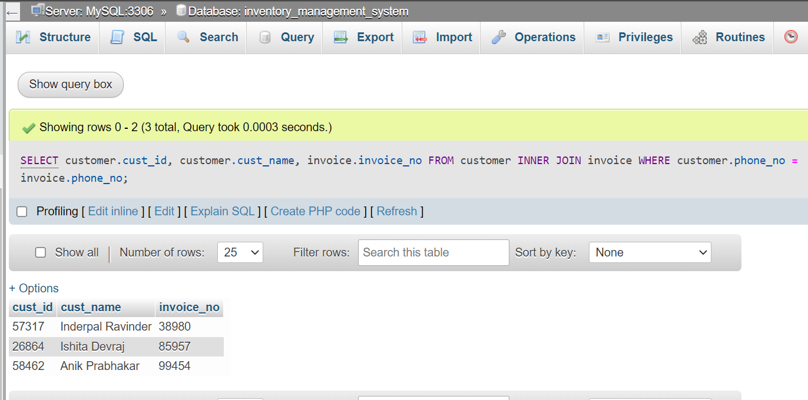

b. List all the cost prices of products in stock.

Query:

SELECT stock.pid, product.product_name, product.cost_price FROM product INNER JOIN stock WHERE product.product_id = stock.pid;

Screenshot:

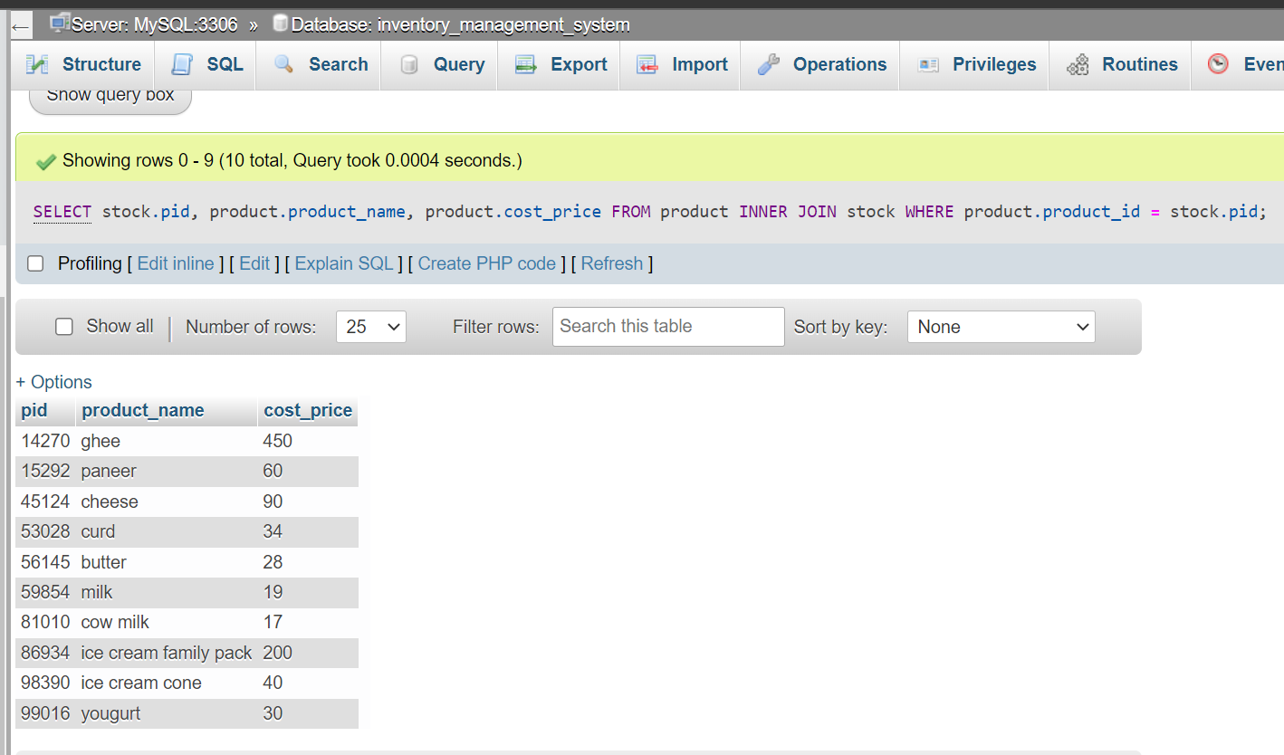

c. List all customer names who visit a certain vendor.

Query:

SELECT customer.cust_name, vendor.vendor_id FROM vendor INNER JOIN customer WHERE customer.cust_id = vendor.cust_id AND vendor.vendor_id = 75071;

Screenshot:

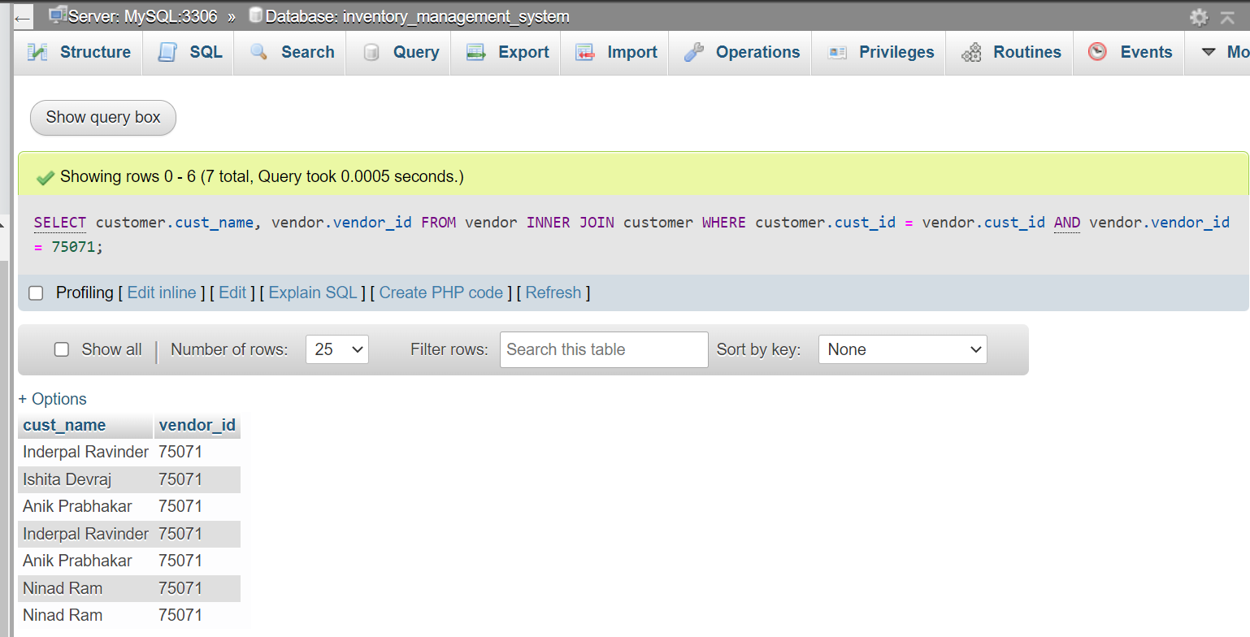

d. List quantity of all products in stock along with product details.

Query:

SELECT product.product_name, stock.pqty FROM product INNER JOIN stock WHERE product.product_id = stock.pid;

Screenshot:

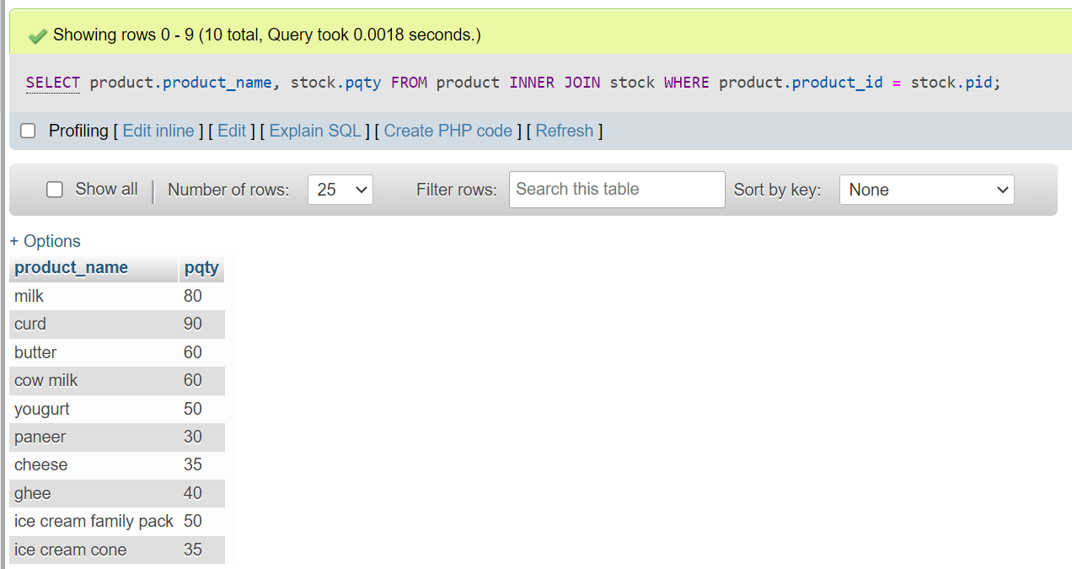

**7. Aggregate Functions:**

a. The total number of products each vendor sold.

Query:

SELECT vendor.vendor_id, vendor.fname, vendor.lname, COUNT(DISTINCT vendor.product_id) FROM vendor GROUP BY vendor.vendor_id;

Screenshot:

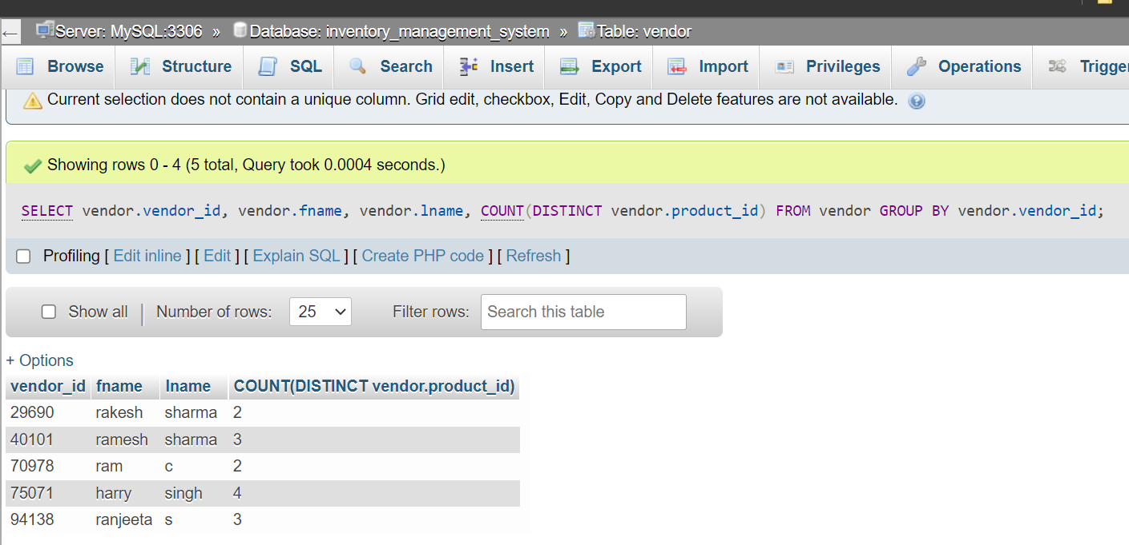

b. The number of customers who bought milk.

Query:

SELECT COUNT(DISTINCT vendor.cust_id) CountOfMilk FROM vendor INNER JOIN product WHERE product.product_name LIKE "%milk%";

Screenshot:

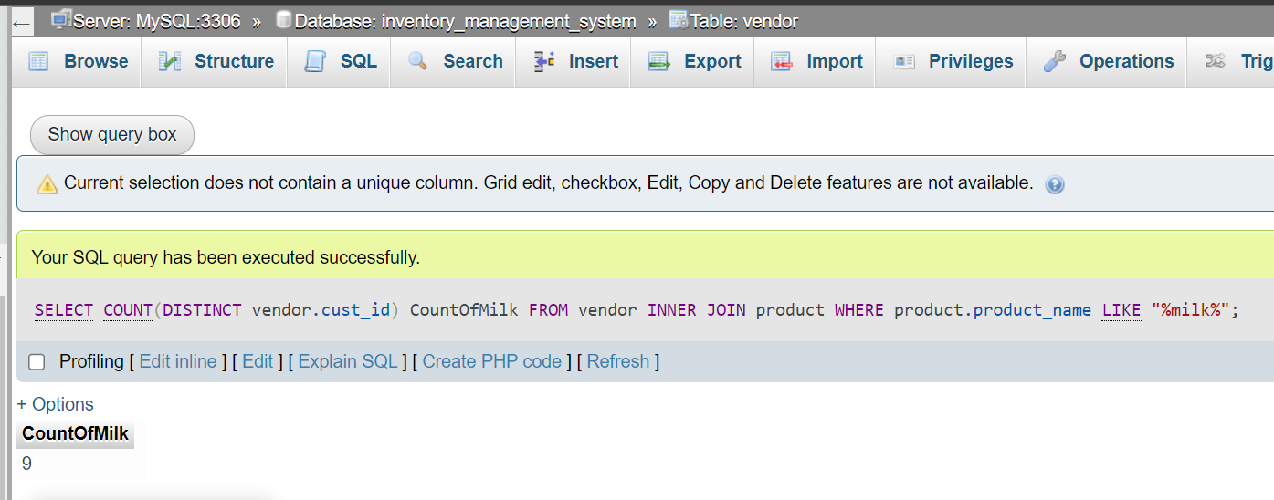

c. The vendor who sells to maximum number of customers.

Query:

SELECT vendor.vendor_id, COUNT(DISTINCT vendor.cust_id) AS MaximumCustomers FROM vendor GROUP BY vendor.vendor_id HAVING COUNT(DISTINCT vendor.cust_id) = (SELECT MAX(Customers.MaximumCustomers) FROM (SELECT vendor.vendor_id, COUNT(DISTINCT vendor.cust_id) as MaximumCustomers FROM vendor GROUP BY vendor.vendor_id) AS Customers);

Screenshot:

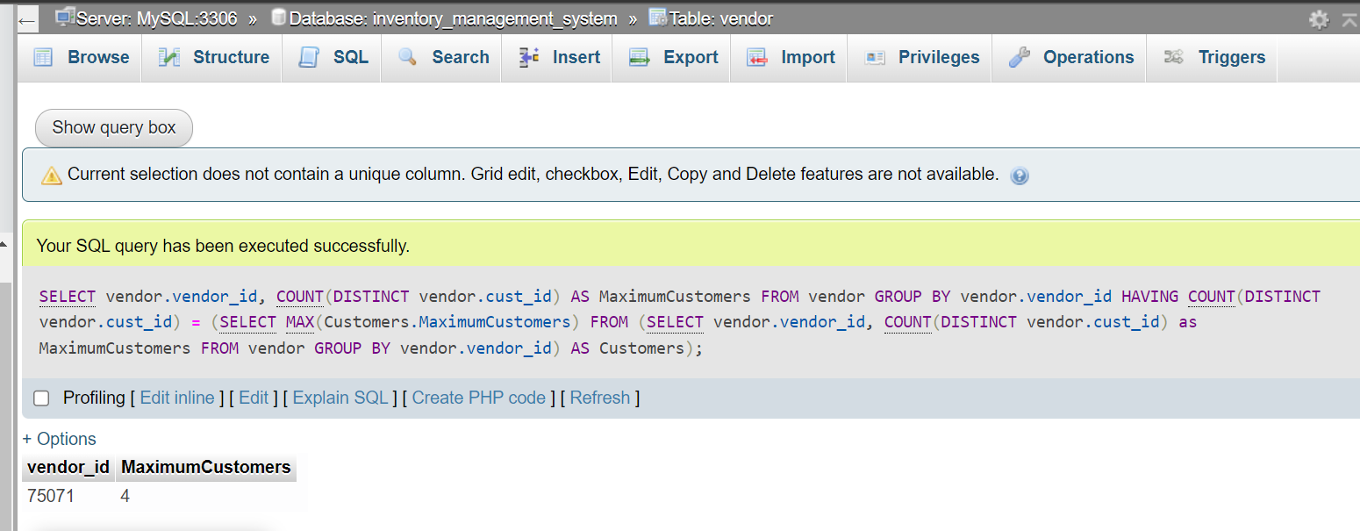

d. Average cost price of all Amul products.

Query:

SELECT AVG(product.cost_price) AS AverageCostPrice, product.manufacturer FROM product WHERE product.manufacturer = “Amul” GROUP BY product.manufacturer;

Screenshot:

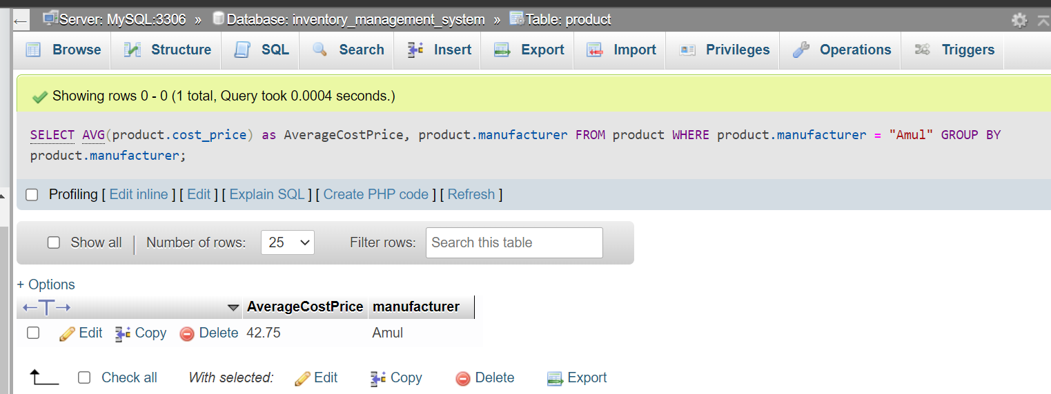

**8. Set Operations:**

a. Common products sold by vendor 75071 and 40101.

Query:

SELECT DISTINCT vendor.product_id FROM vendor WHERE vendor.vendor_id = 75071 AND vendor.product_id IN (SELECT vendor.product_id FROM vendor WHERE vendor.vendor_id = 40101);

Screenshot:

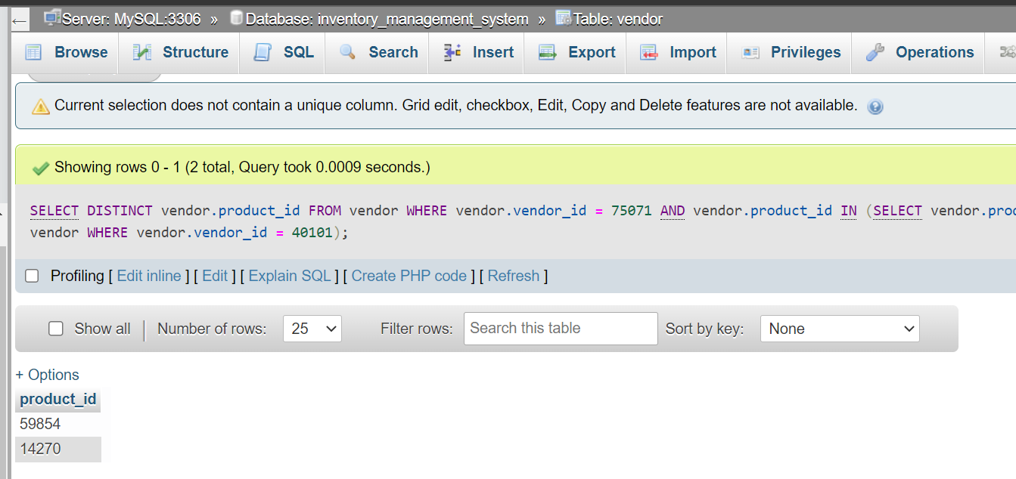

b. Products sold by Amul or Milky Mist.

Query:

SELECT product.product_id, product.product_name, product.manufacturer FROM product WHERE product.manufacturer = "Amul" UNION SELECT product.product_id, product.product_name, product.manufacturer FROM product WHERE product.manufacturer = "Milky Mist";

Screenshot:

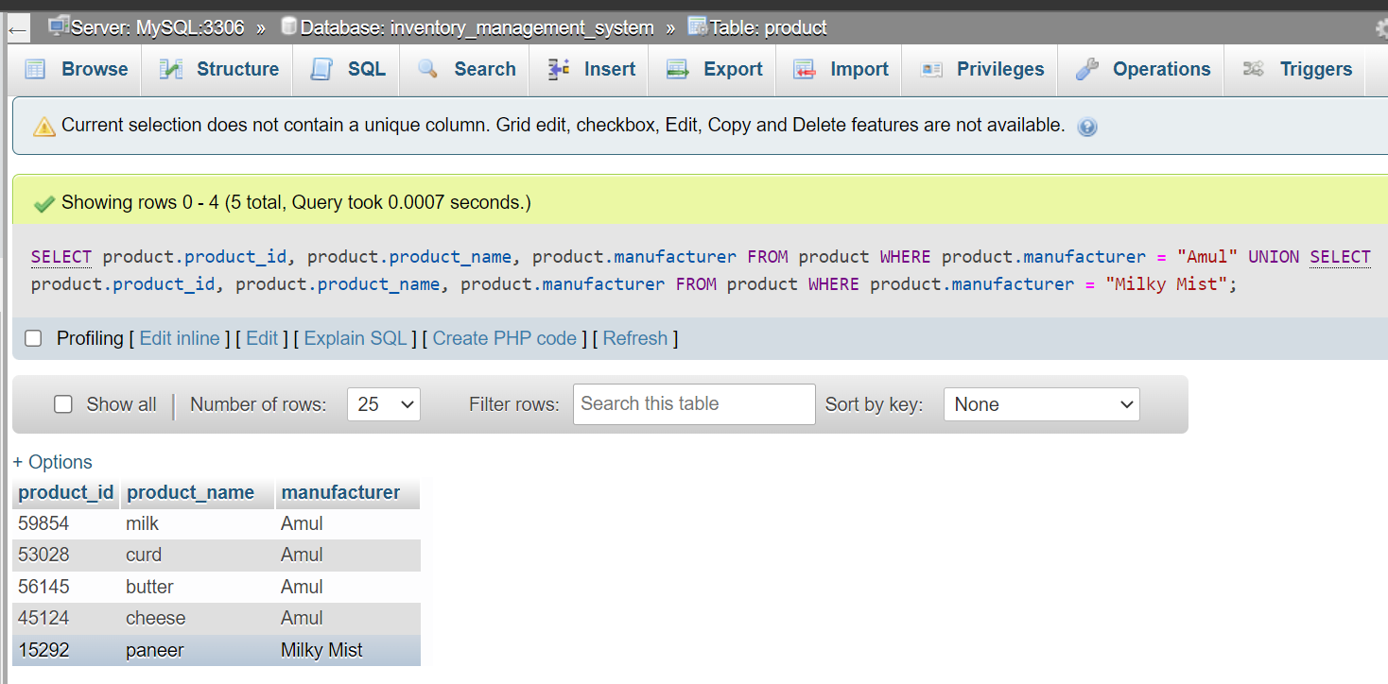

c. Products not sold by Nandini.

Query:

SELECT product.product_id, product.product_name, product.manufacturer FROM product WHERE product.manufacturer NOT IN (SELECT product.manufacturer FROM product WHERE product.manufacturer = "Nandini");

Screenshot:

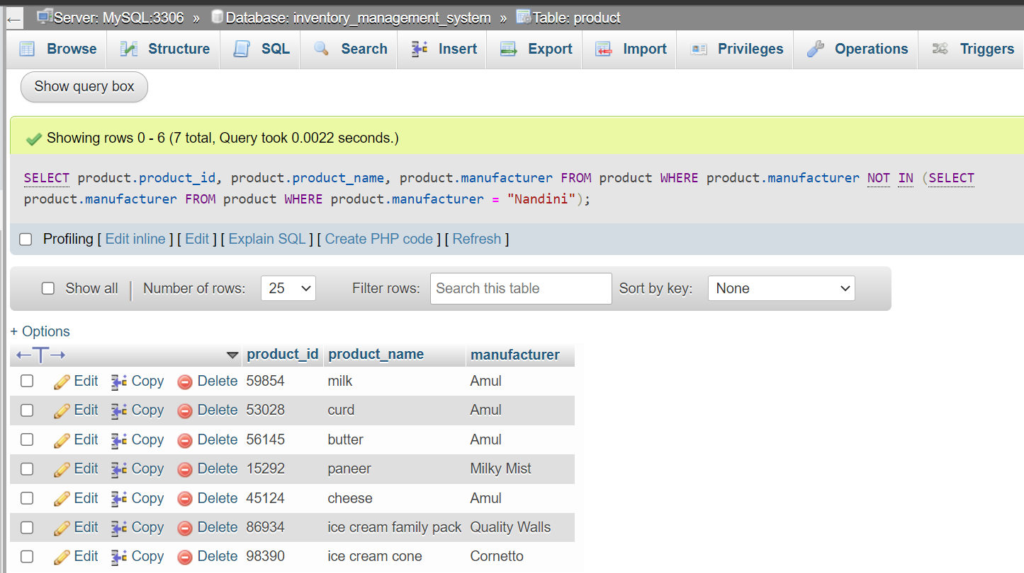

d. Vendors who don’t have any sold products in invoice.

Query:

SELECT DISTINCT vendor.fname, vendor.lname, vendor.vendor_id FROM vendor WHERE vendor.vendor_id NOT IN (SELECT invoice.vendor_id FROM invoice);

Screenshot:

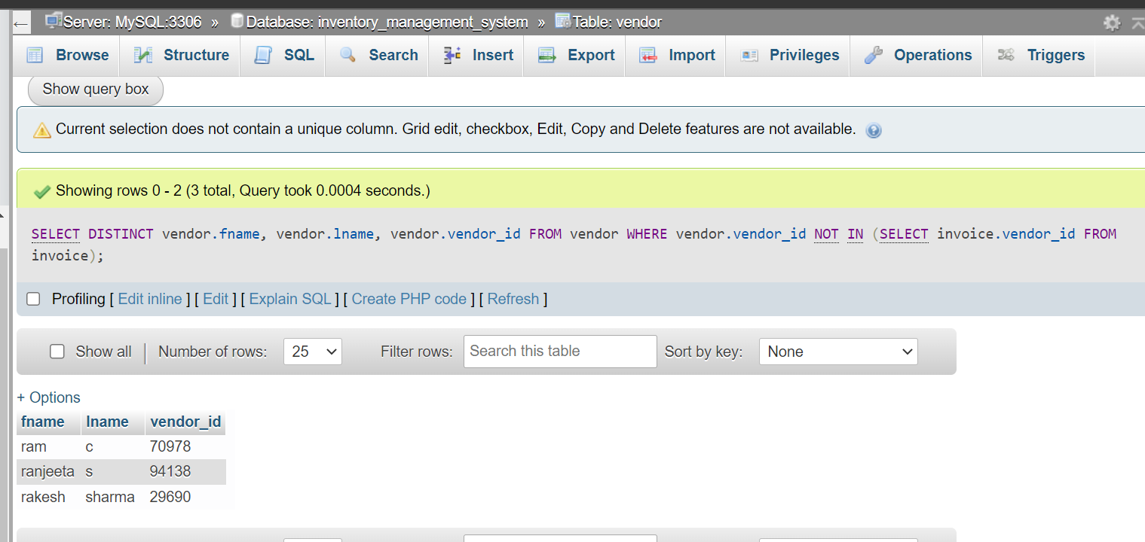

**9. Functions and Procedures:**

a. Function which shows which stocks need to be re-filled ie if the stock quantity is less than 50

Function creation:

DELIMITER $

CREATE FUNCTION check_stock(qty int)

RETURNS VARCHAR(50)

BEGIN

DECLARE refill VARCHAR(50);

IF qty < 50 THEN

SET refill = "re-fill needed";

ELSE

SET refill = "no re-fill needed";

END IF;

RETURN refill;

END $

DELIMITER ;

Function call:

SELECT stock.pid, stock.pqty, check_stock(stock.pqty) FROM stock;

Screenshots:

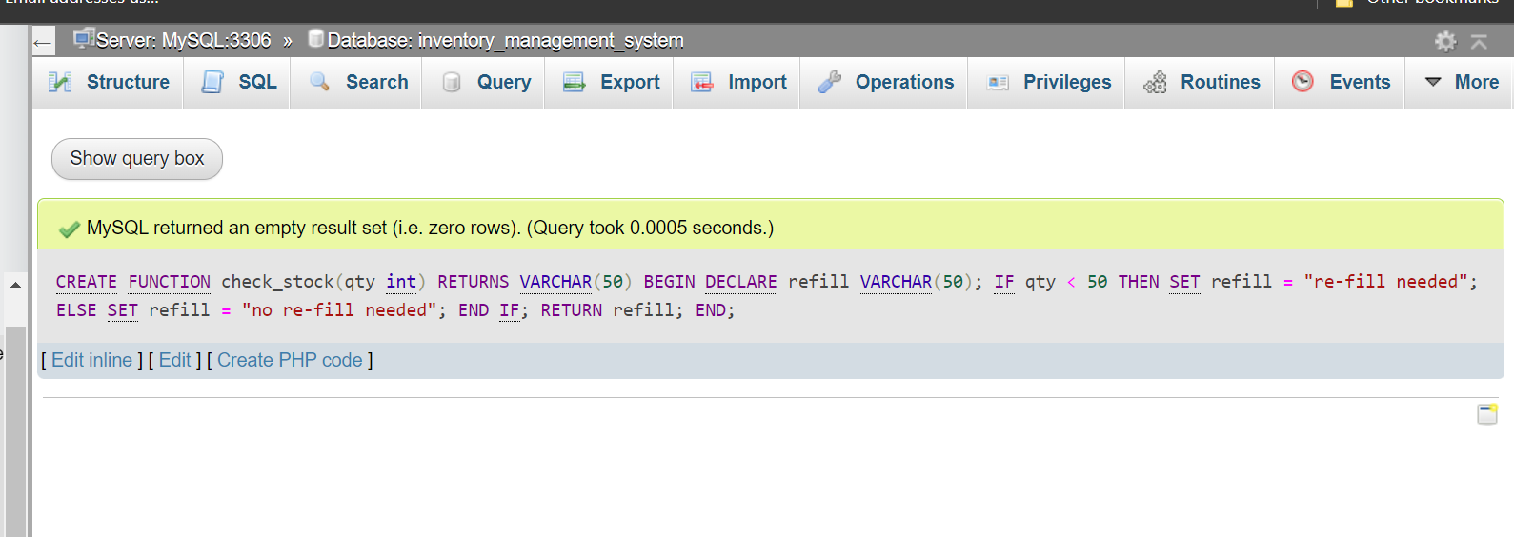

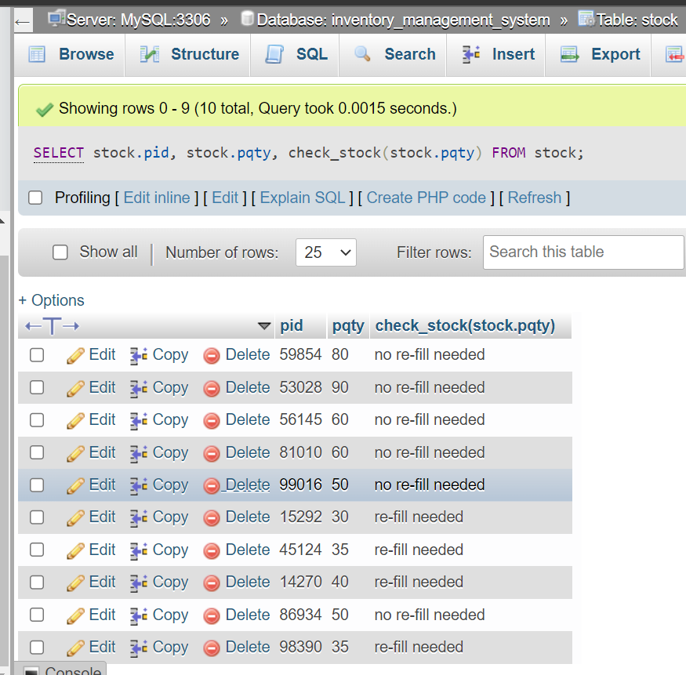

b. Procedure to update the product quantity to given value and purchase date to current date if the quantity is less than 50.

Procedure creation:

DELIMITER $

CREATE PROCEDURE update_qty(IN qty int)

BEGIN

UPDATE stock SET stock.pqty = qty, stock.purchase_date = CURRENT_DATE WHERE stock.pqty < 50;

END $

DELIMITER ;

Procedure call:

CALL update_qty(50);

Screenshots:

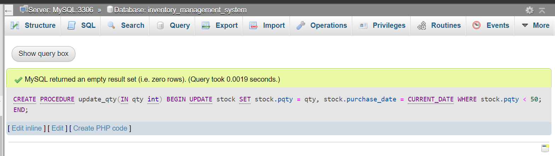

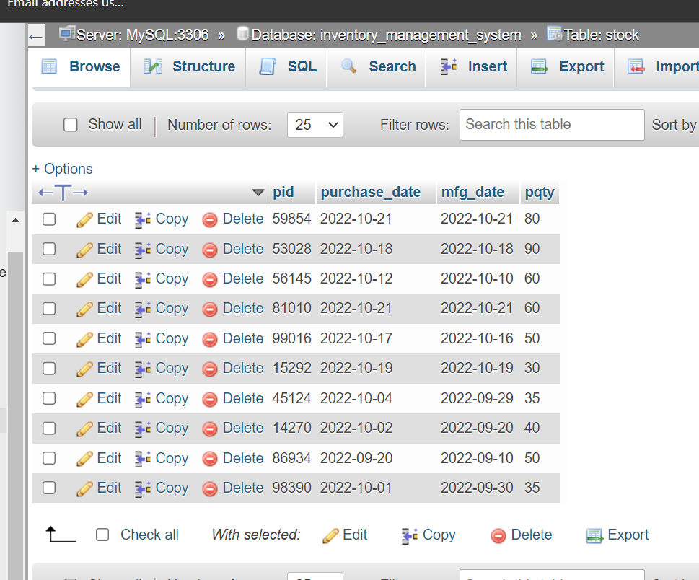

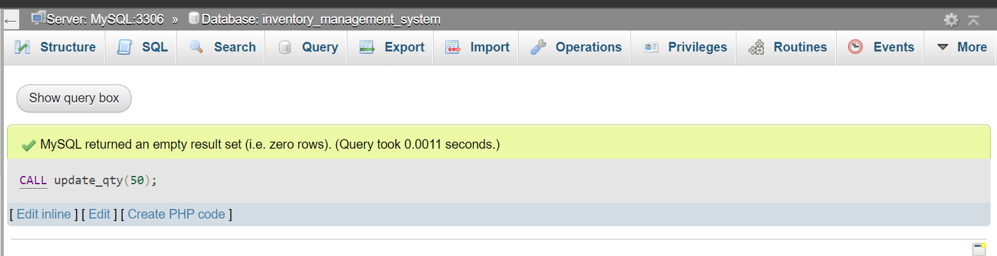

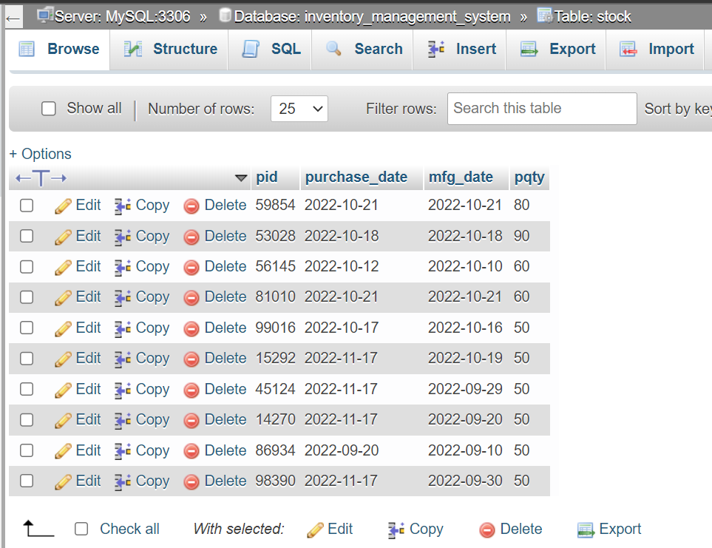

**10. Triggers and Cursors:**

a. If manufacturing or purchase date is greater than the current date and manufacturing date should be less than purchase date then show an error.

Trigger creation:

DELIMITER $

CREATE TRIGGER on_insert_stock

BEFORE INSERT

ON stock FOR EACH ROW

BEGIN

DECLARE err_msg1 varchar(100);

DECLARE err_msg2 varchar(100);

DECLARE err_msg3 varchar(100);

SET err_msg1 = "Mfg/Purchase Date must be before the current date";

SET err_msg2 = "Mfg Date should be before Purchase Date";

SET err_msg3 = "Product quantity should be minimum 50";

IF (new.purchase_date > CURRENT_DATE OR new.mfg_date > CURRENT_DATE) THEN

SIGNAL SQLSTATE '45000'

SET MESSAGE_TEXT = err_msg1;

ELSEIF new.mfg_date > new.purchase_date THEN

SIGNAL SQLSTATE '45000'

SET MESSAGE_TEXT = err_msg2;

ELSEIF new.pqty < 50 THEN

SIGNAL SQLSTATE '45000'

SET MESSAGE_TEXT = err_msg3;

END IF;

END $

DELIMITER ;

Incorrect insert:

INSERT INTO stock VALUES (86934, '2022-11-01', '2022-12-01', 50);

INSERT INTO stock VALUES (86934, '2022-12-11', '2022-12-01', 50);

INSERT INTO stock VALUES (86934, '2022-10-01', '2022-11-01', 50);

INSERT INTO stock VALUES (86934, '2022-11-10', '2022-11-01', 5);

Correct insert:

INSERT INTO stock VALUES (86934, '2022-11-01', '2022-11-10', 50);

Screenshots:

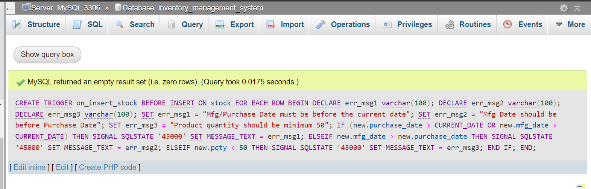

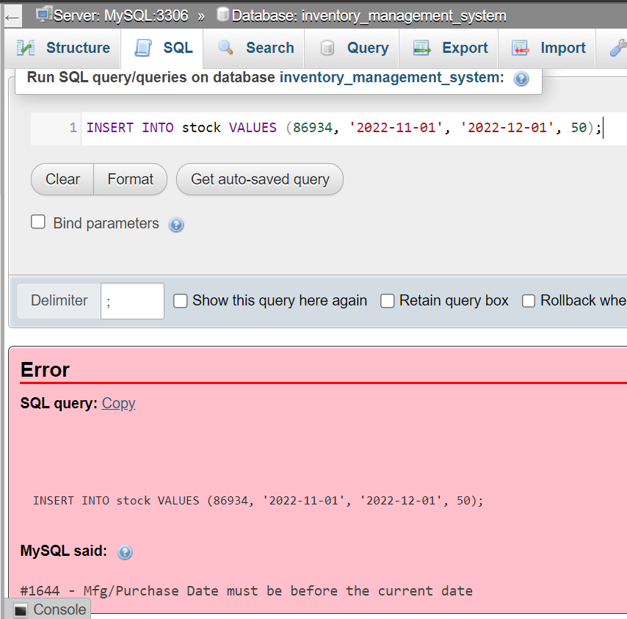

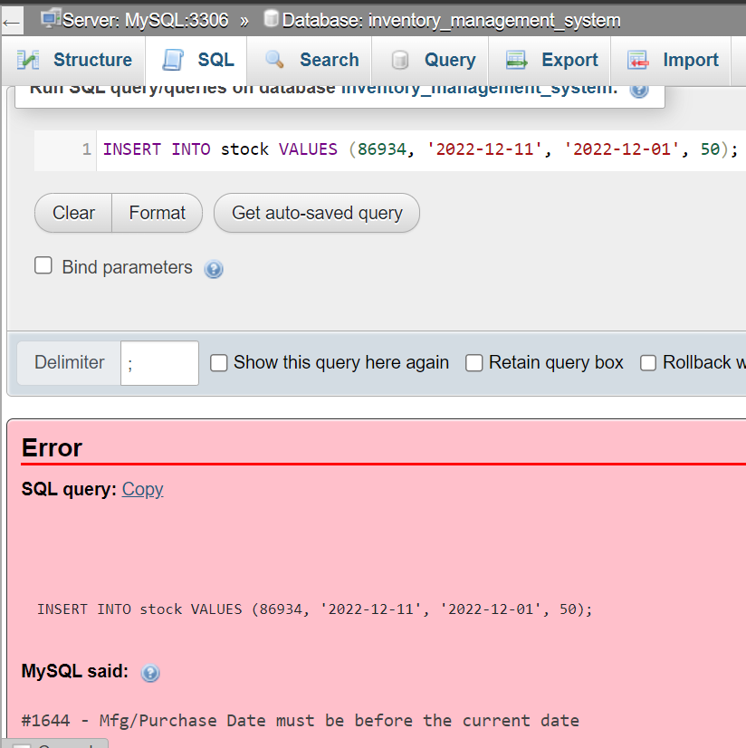

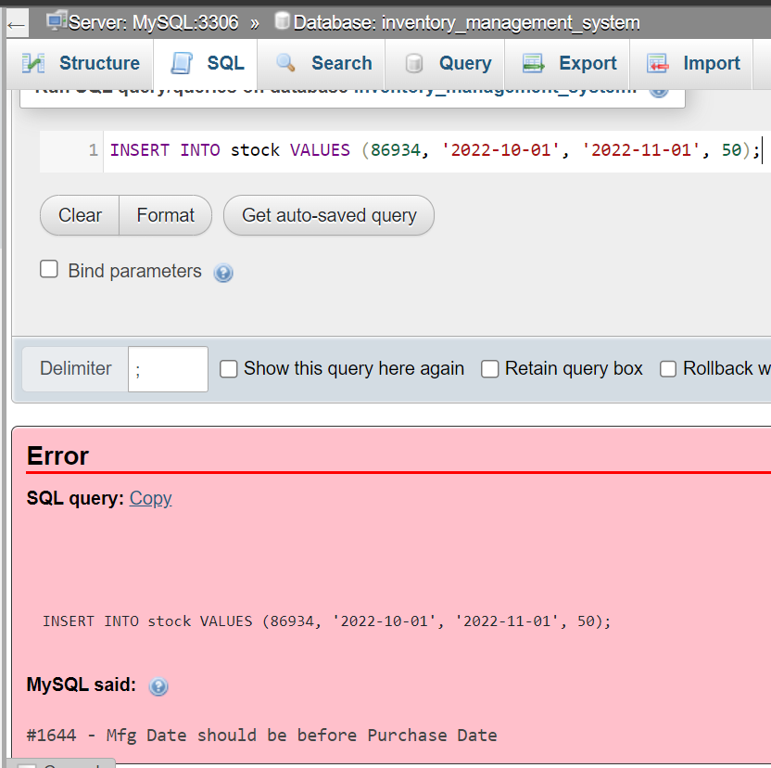

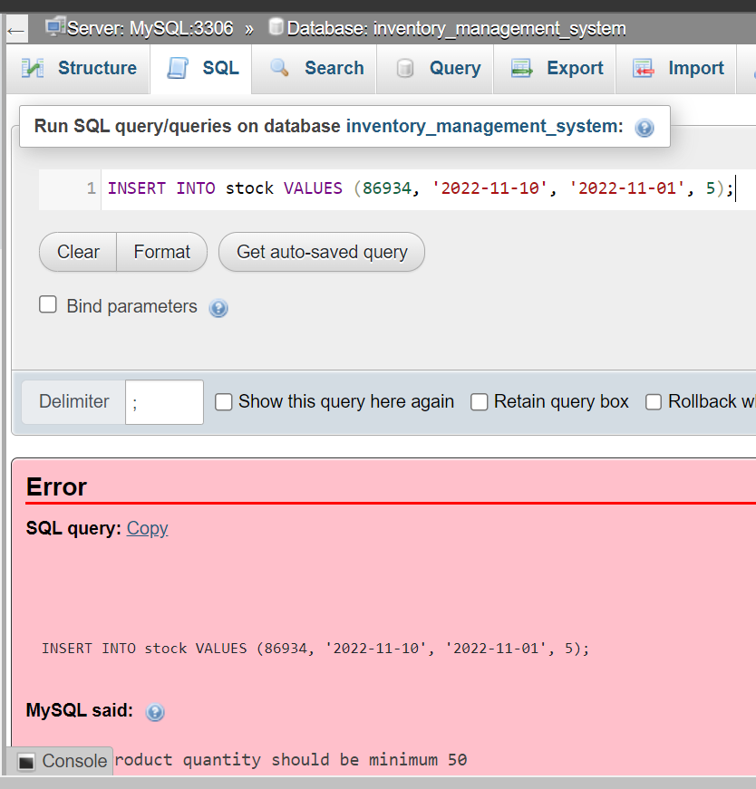

b. Procedure with a Cursor to delete entries in vendor table with NULL values for product and customer that have at least one entry in the invoice table.

Procedure creation:

DELIMITER $

CREATE PROCEDURE del_null()

BEGIN

DECLARE vid int;

DECLARE finished INTEGER DEFAULT 0;

DECLARE del_null CURSOR FOR

SELECT DISTINCT vendor.vendor_id FROM vendor INNER JOIN invoice WHERE vendor.vendor_id = invoice.vendor_id and vendor.product_id IS NULL;

DECLARE CONTINUE HANDLER

FOR NOT FOUND SET finished = 1;

OPEN del_null;

getRows: LOOP

FETCH del_null INTO vid;

IF finished THEN

LEAVE getRows;

END IF;

DELETE FROM vendor WHERE vendor.vendor_id = vid AND vendor.product_id IS NULL;

END LOOP;

CLOSE del_null;

END $

DELIMITER ;

Procedure Call:

CALL del_null();

Screenshots:

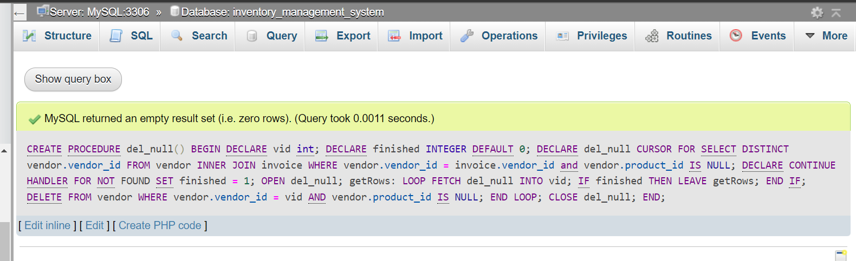

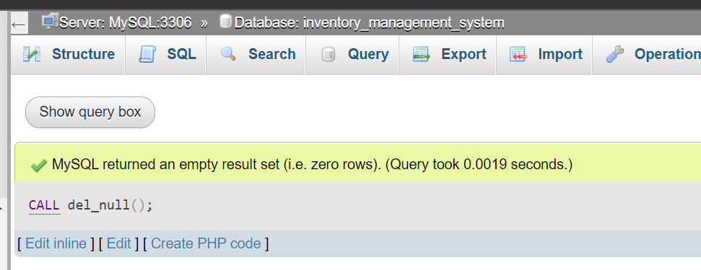

Before procedure call:

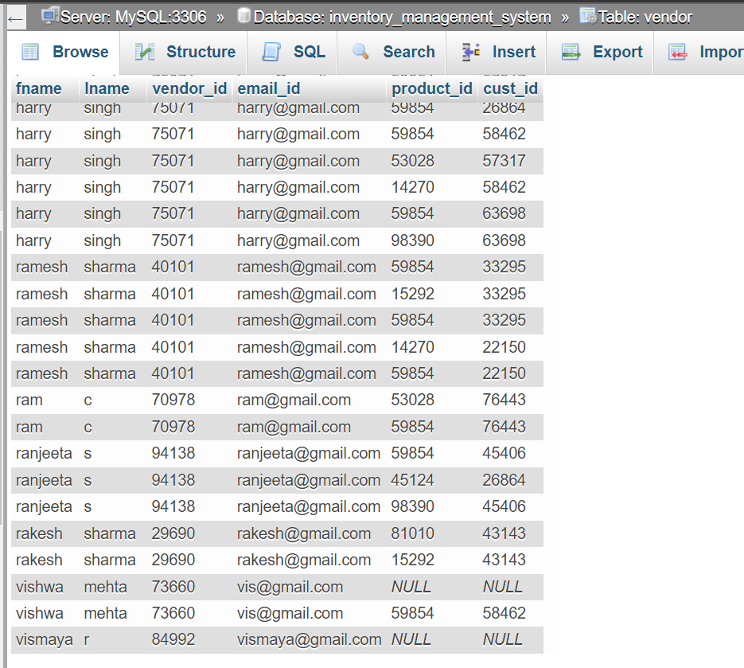

After procedure call:

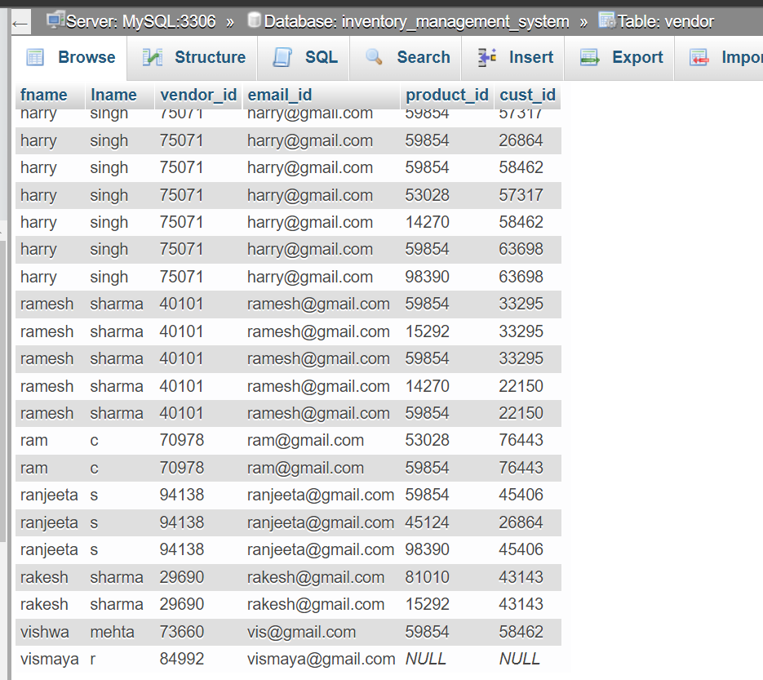

**11. Developing a Frontend**

1. app.py

import streamlit as st

from database import check_login, add_login

def main():

    st.title("Inventory Management System")

    col1, col2 = st.columns(2)

    with col1:

        st.subheader("Login")

        email0 = st.text_input("Email: ")

        password0 = st.text_input("Password: ", type = "password")

        if st.button("Login"):

            check_login(email0, password0)

    with col2:

        st.subheader("SignUp:")

        fname = st.text_input("First Name:")

        lname = st.text_input("Last Name")

        email = st.text_input("Email:")

        password = st.text_input("Password:", type = "password")

        if st.button("Signup"):

            add_login(fname, lname, email, password)

if __name__ == '__main__':

    main()

2. database.py

import streamlit as st

import mysql.connector

import random

mydb = mysql.connector.connect(

    host = "localhost",

    user = "root",

    password = "",

    database = "inventory_management_system"

)

c = mydb.cursor()

from reload import reload

def check_login(email, password):

    # print(email)

    values = email

    c.execute("SELECT * FROM login WHERE email_id = %s", (values,))

    passws = c.fetchall()

    for passw in passws:

        if passw[1] == password:

            reload("home")

            break

        else:

            st.error("Incorrect credentials, please try again.")

def add_login(fn, ln, email, password):

    values = email

    c.execute("SELECT * FROM login WHERE email_id = %s", (values,))

    x = c.fetchall()

    if x != []:

        print(x)

        st.error("User already exists :/")

    else:

        c.execute("INSERT INTO login (email_id, pass) VALUES (%s,%s)", (email, password))

        vid = random.randint(10000, 99999)

        c.execute("INSERT INTO vendor (fname, lname, vendor_id, email_id) VALUES (%s, %s, %s, %s) ", (fn, ln, vid, email))

        st.success("Successfully Added User")

    # else:

    #     st.error("User already exists :/")

def update_password(mail, old_pass, new_pass):

    c.execute("UPDATE login SET pass = %s WHERE email_id = %s AND pass = %s", (new_pass, mail, old_pass))

    if c.rowcount is not None:

        st.success("Password updated successfully!")

def view_stock():

    c.execute("SELECT * FROM stock")

    data = c.fetchall()

    return data

def add_stock(pid, pdate, mdate, qty):

    c.execute("INSERT INTO stock VALUES (%s, %s, %s, %s)", (pid, pdate, mdate, qty))

    st.success("Values inserted")

def prod_not_in_stock():

    c.execute("SELECT product.product_id FROM product WHERE product.product_id NOT IN (SELECT stock.pid FROM stock)")

    data = c.fetchall()

    return data

def prod_in_stock():

    c.execute("SELECT product.product_id FROM product WHERE product.product_id IN (SELECT stock.pid FROM stock)")

    data = c.fetchall()

    return data

def get_product(pid):

    c.execute("SELECT * FROM product WHERE product.product_id = {}".format(pid))

    data = c.fetchall()

    print(data)

    return data

def get_stock(pid):

    c.execute("SELECT * FROM stock WHERE stock.pid = {}".format(pid))

    data = c.fetchall()

    print(data)

    return data

def update_stock(pid, pdate, mdate, qty):

    c.execute("UPDATE stock SET purchase_date = %s, mfg_date = %s, pqty = %s WHERE pid = %s", (pdate, mdate, qty, pid))

    st.success("Stock updated successfully")

def remove_stock(pid):

    c.execute("DELETE FROM stock WHERE stock.pid = {}".format(pid))

    st.success("Product Deleted successfully")

def view_product():

    c.execute("SELECT * FROM product")

    data = c.fetchall()

    return data

def add_product(pid, pname, cp, mfg, mrp):

    c.execute("INSERT INTO product VALUES (%s, %s, %s, %s, %s)", (pid, pname, cp, mfg, mrp))

    st.success("Inserted Product")

def get_product_names():

    c.execute("SELECT product.product_name FROM product")

    data = c.fetchall()

    return data

def get_product_id(pname):

    value = pname

    c.execute("SELECT product.product_id FROM product WHERE product_name = %s", (value,))

    data = c.fetchall()

    return data[0][0]

def get_prod_mrp(pid):

    value = pid

    c.execute("SELECT product.mrp FROM product WHERE product.product_id = %s", (value,))

    data = c.fetchall()

    return data[0][0]

def update_prod_price(pid, cp):

    c.execute("UPDATE product SET product.cost_price = %s WHERE product.product_id = %s", (cp, pid))

    st.success("Cost price updated")

def view_customer():

    c.execute("SELECT * FROM customer")

    data = c.fetchall()

    return data

def add_customer(cid, pn, mail, cname, sno, sname, pin):

    c.execute("INSERT INTO customer VALUES (%s, %s, %s, %s, %s, %s, %s)", (cid, pn, mail, cname, sno, sname, pin))

    st.success("Inserted Customer")

def get_customer(cid):

    c.execute("SELECT * FROM customer WHERE customer.cust_id = {}".format(cid))

    data = c.fetchall()

    print(data)

    return data

def get_cust_names():

    c.execute("SELECT customer.cust_name FROM customer")

    data = c.fetchall()

    return data

def get_cust_ids(cname):

    value = cname

    c.execute("SELECT customer.cust_id FROM customer WHERE customer.cust_name = %s", (value,))

    data = c.fetchall()

    return data

def update_customer(cid, phno, email, cname, stno, stname, pin):

    c.execute("UPDATE customer SET phone_no = %s, cust_email_id = %s, cust_name = %s, str_no = %s, str_name = %s, pincode = %s WHERE cust_id = %s", (phno, email, cname, stno, stname, pin, cid))

    st.success("Successfully Updated Customer")

def view_invoice():

    c.execute("SELECT * FROM invoice")

    data = c.fetchall()

    return data

def get_vendor_id(mail):

    print(mail)

    c.execute("SELECT DISTINCT vendor.vendor_id FROM vendor WHERE vendor.email_id = %s", (mail, ))

    data = c.fetchall()

    print("data", data[0][0])

    return data[0][0]

def add_invoice(pid, ino, idate, sp, pqty, dis, phno, vid):

    c.execute("INSERT INTO invoice VALUES (%s, %s, %s, %s, %s, %s, %s, %s)", (pid, ino, idate, sp, pqty, dis, phno, vid))

    c.execute("SELECT customer.cust_id FROM customer WHERE customer.phone_no = %s", (phno,))

    cid = c.fetchall()[0][0]

    c.execute("SELECT DISTINCT vendor.fname, vendor.lname, vendor.vendor_id, vendor.email_id FROM vendor WHERE vendor.vendor_id = %s", (vid,))

    d = c.fetchall()

    fn, ln, vid0, mail = d[0][0], d[0][1], d[0][2], d[0][3]

    c.execute("INSERT INTO vendor VALUES (%s, %s, %s, %s, %s, %s)", (fn, ln, vid0, mail, pid, cid))

    st.success("Invoice inserted successfully")

def get_invoice(iid):

    c.execute("SELECT * FROM invoice WHERE invoice.invoice_no = {}".format(iid))

    data = c.fetchall()

    return data

def get_phnos():

    c.execute("SELECT customer.phone_no FROM customer")

    data = c.fetchall()

    return data

3. home.py

import streamlit as st

from database import *

import pandas as pd

import random

st.title("Welcome to ListAll")

def main():

    menu = ["View Stock", "Add item to stock", "Update Stock", "Remove Stock", "View Products", "Add Product", "Update Product Price", "View Customers", "Add Customer", "Update Customer", "View Invoice", "Add Invoice", "Change Password"]

    choice = st.sidebar.selectbox("Menu", menu)

    if choice == "View Stock":

        st.subheader("Current Stock:")

        data = view_stock()

        df = pd.DataFrame(data, columns = ['pid', 'purchase_date', 'mfg_date', 'pqty'])

        st.dataframe(df)

    elif choice == "Add item to stock":

        st.subheader("Add New Product to Current Stock:")

        list_of_products = [i[0] for i in prod_not_in_stock()]

        prod = st.selectbox("Products that can be added to stock", list_of_products)

        result = get_product(prod)

        if result:

            pid = st.text_input("Product ID:", result[0][0])

            pname = st.text_input("Product Name:", result[0][1])

            pur_date = st.text_input("Purchase Date(YYYY-MM-DD):")

            mfg_date = st.text_input("Manufacturing Date(YYYY-MM-DD):")

            qty = st.text_input("Product Quantity:")

            if st.button("Add"):

                add_stock(pid, pur_date, mfg_date, qty)

        with st.expander("View Updated table"):

            data = view_stock()

            df = pd.DataFrame(data, columns = ['pid', 'purchase_date', 'mfg_date', 'pqty'])

            st.dataframe(df)

    elif choice == "Update Stock":

        st.subheader("Update Stock:")

        list_of_products = [i[0] for i in prod_in_stock()]

        prod = st.selectbox("Products that can be updated in stock", list_of_products)

        result = get_stock(prod)

        res = get_product(prod)

        # print(result[0])

        if result:

            # print(type(result[0][1]), type(result[0][2]))

            pid = result[0][0]

            pdate = result[0][1]

            mdate = result[0][2]

            pqty = result[0][3]

            col1, col2= st.columns(2)

            with col1:

                pid0 = st.text_input("Product ID:", pid, disabled = True)

                new_pdate = st.text_input("Purchase Date(YYYY-MM-DD):", pdate)

            with col2:

                pname = st.text_input("Product Name:", res[0][1], disabled = True)

                new_mdate = st.text_input("Manufacturing Date(YYYY-MM-DD):", mdate)

            new_pqty = st.text_input("Product Quantity:", pqty)

            if st.button("Update"):

                update_stock(pid0, new_pdate, new_mdate, new_pqty)

        with st.expander("View Updated table"):

            data = view_stock()

            df = pd.DataFrame(data, columns = ['pid', 'purchase_date', 'mfg_date', 'pqty'])

            st.dataframe(df)

    elif choice == "Remove Stock":

        st.subheader("Remove Stock:")

        list_of_products = [i[0] for i in prod_in_stock()]

        prod = st.selectbox("Products that can be added to stock", list_of_products)

        result = get_product(prod)

        if result:

            pid = result[0][0]

            if st.button("Remove "+str(result[0][1])):

                remove_stock(pid)

        with st.expander("View Updated table"):

            data = view_stock()

            df = pd.DataFrame(data, columns = ['pid', 'purchase_date', 'mfg_date', 'pqty'])

            st.dataframe(df)

    elif choice == "View Products":

        st.subheader("Products:")

        data = view_product()

        df = pd.DataFrame(data, columns = ['product_id', 'product_name', 'cost_price', 'manufacturer', 'mrp'])

        st.dataframe(df)

    elif choice == "Add Product":

        st.subheader("Enter product details:")

        gen_pid = random.randint(10000, 99999)

        d = get_product(gen_pid)

        if not d:

            print(gen_pid)

            pid = st.text_input("Product ID:", gen_pid, disabled = True)

        else:

            st.error("Please reload the page.")

        pname = st.text_input("Product Name:")

        cp = st.text_input("Cost Price:")

        mfg = st.text_input("Manufacturer Name:")

        mrp = st.text_input("MRP:")

        if st.button("Add"):

            add_product(pid, pname, cp, mfg, mrp)

        with st.expander("View Updated table"):

            data = view_product()

            df = pd.DataFrame(data, columns = ['product_id', 'product_name', 'cost_price', 'manufacturer', 'mrp'])

            st.dataframe(df)

    elif choice == "Update Product Price":

        st.subheader("Update Product:")

        list_of_products = [i[0] for i in get_product_names()]

        pname = st.selectbox("Product Name:", list_of_products)

        prod = get_product_id(pname)

        result = get_product(prod)

        # print(result[0])

        if result:

            # print(type(result[0][1]), type(result[0][2]))

            pid = result[0][0]

            pname = result[0][1]

            cp = result[0][2]

            mfg = result[0][3]

            mrp = result[0][4]

            col1, col2= st.columns(2)

            with col1:

                pid0 = st.text_input("Product ID:", pid, disabled = True)

                pname0 = st.text_input("Name:", pname, disabled = True)

                mrp0 = st.text_input("MRP:", mrp, disabled = True)

            with col2:

                new_cp = st.text_input("Cost Price:", cp)

                mfg0 = st.text_input("Manufacturer Name:", mfg, disabled = True)

            if st.button("Update"):

                update_prod_price(pid0, new_cp)

            with st.expander("View Updated table"):

                data = view_product()

                df = pd.DataFrame(data, columns = ['product_id', 'product_name', 'cost_price', 'manufacturer', 'mrp'])

                st.dataframe(df)

    elif choice == "View Customers":

        st.subheader("Customers:")

        data = view_customer()

        df = pd.DataFrame(data, columns = ['cust_id', 'phone_no', 'cust_email_id', 'cust_name', 'str_no', 'str_name', 'pincode'])

        st.dataframe(df)

    elif choice == "Add Customer":

        st.subheader("Enter customer details:")

        gen_cid = random.randint(10000, 99999)

        d = get_customer(gen_cid)

        if not d:

            print(gen_cid)

            cid = st.text_input("Customer ID:", gen_cid, disabled = True)

        else:

            st.error("Please reload the page.")

        cname = st.text_input("Customer Name:")

        pn = st.text_input("Phone Number:")

        mail = st.text_input("Email ID:")

        col1, col2, col3 = st.columns(3)

        with col1:

            sno = st.text_input("Street Number:")

        with col2:

            sname = st.text_input("Street Name:")

        with col3:

            pin = st.text_input("Pincode:")

        if st.button("Add"):

            add_customer(cid, pn, mail, cname, sno, sname, pin)

        with st.expander("View Updated table"):

            data = view_customer()

            df = pd.DataFrame(data, columns = ['cust_id', 'phone_no', 'cust_email_id', 'cust_name', 'str_no', 'str_name', 'pincode'])

            st.dataframe(df)

    elif choice == "Update Customer":

        st.subheader("Update Customer:")

        list_of_cnames = [i[0] for i in get_cust_names()]

        # print(list_of_cnames)

        cname = st.selectbox("Select customer to be updated", list_of_cnames)

        # print(cname)

        cid = get_cust_ids(cname)

        # print(cid[0][0])

        result = get_customer(cid[0][0])

        # print(result[0])

        if result:

            cid = result[0][0]

            phno = result[0][1]

            email = result[0][2]

            cname = result[0][3]

            stno = result[0][4]

            stname = result[0][5]

            pin = result[0][6]

            cid0 = st.text_input("Customer ID:", cid, disabled = True)

            new_phno = st.text_input("Phone Number", phno)

            new_email = st.text_input("Email ID:", email)

            new_cname = st.text_input("Name:", cname)

            new_stno = st.text_input("Street Number:", stno)

            new_stname = st.text_input("Street Name:", stname)

            new_pin = st.text_input("Pincode:", pin)

            if st.button("Update"):

                update_customer(cid0, new_phno, new_email, new_cname, new_stno, new_stname, new_pin)

        with st.expander("View Updated table"):

            data = view_customer()

            df = pd.DataFrame(data, columns = ['cust_id', 'phone_no', 'cust_email_id', 'cust_name', 'str_no', 'str_name', 'pincode'])

            st.dataframe(df)

    elif choice == "View Invoice":

        st.subheader("Invoice:")

        data = view_invoice()

        df = pd.DataFrame(data, columns = ['prod_id', 'invoice_no', 'invoice_date', 'selling_price', 'prod_qty', 'discount', 'phone_no', 'vendor_id'])

        st.dataframe(df)

    elif choice == "Add Invoice":

        st.subheader("Add Invoice:")

        list_of_products = [i[1] for i in view_product()]

        prod = st.selectbox("Product Name:", list_of_products)

        pid = get_product_id(prod)

        gen_iid = random.randint(10000, 99999)

        d = get_invoice(gen_iid)

        if not d:

            print(gen_iid)

            iid = st.text_input("Invoice ID:", gen_iid, disabled = True)

        else:

            st.error("Please reload the page.")

        idate = st.text_input("Invoice Date (YYYY-MM-DD):")

        dis = st.text_input("Discount Given(%):")

        mrp = get_prod_mrp(pid)

        if dis:

            dis = float(dis) * 0.01

            sp = mrp - (mrp * dis)

            sp0 = st.text_input("Selling Price:", sp, disabled = True)

        pqty = st.text_input("Product Quantity:")

        list_of_phnos = [i[0] for i in get_phnos()]

        pno = st.selectbox("Customer Phone Number:", list_of_phnos)

        mail = st.text_input("Vendor Email ID:")

        # vid = 0

        if mail:

            vid = get_vendor_id(mail)

            # pass

        # phno = get_cus_phone(pno)

        if st.button("Add Invoice"):

            add_invoice(pid, iid, idate, sp0, pqty, dis, pno, vid)

        with st.expander("View Updated Invoice"):

            data = view_invoice()

            df = pd.DataFrame(data, columns = ['prod_id', 'invoice_no', 'invoice_date', 'selling_price', 'prod_qty', 'discount', 'phone_no', 'vendor_id'])

            st.dataframe(df)

    elif choice == "Change Password":

        st.subheader("Enter New Credentials Below:")

        email = st.text_input("Email:")

        old_pass = st.text_input("Old Password:", type = "password")

        new_pass = st.text_input("New Password:", type = "password")

        if st.button("Change Password"):

            update_password(email, old_pass, new_pass)

    else:

        st.subheader("Home Page")

if __name__ == '__main__':

    main()

4. reload.py

import streamlit as st

import os

import keyboard

import threading

import time

wait_second = 10

def threadFunc():

   time.sleep(wait_second)

def reload(page):

    th = threading.Thread(target=threadFunc)

    th.start()

    os.system(r"streamlit run " + page + ".py")

    th.join()

Screenshots:

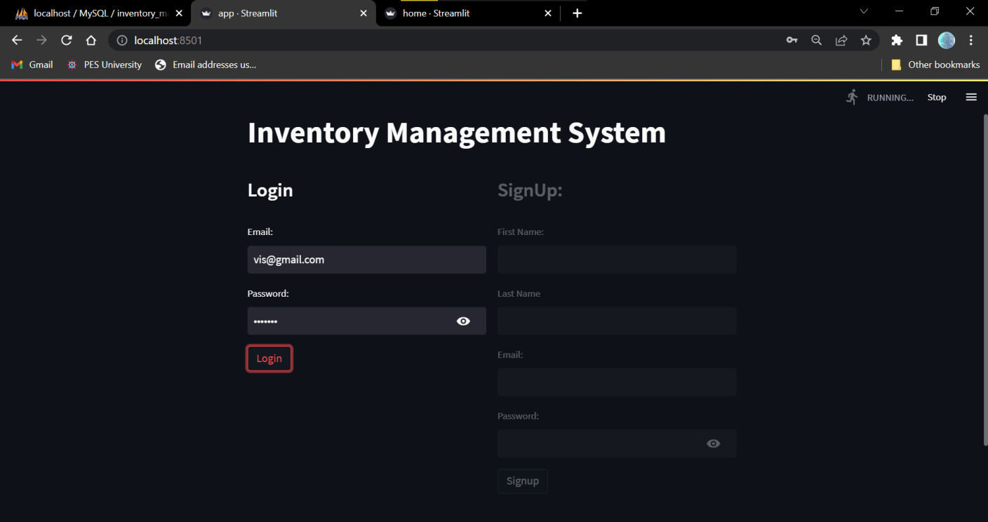

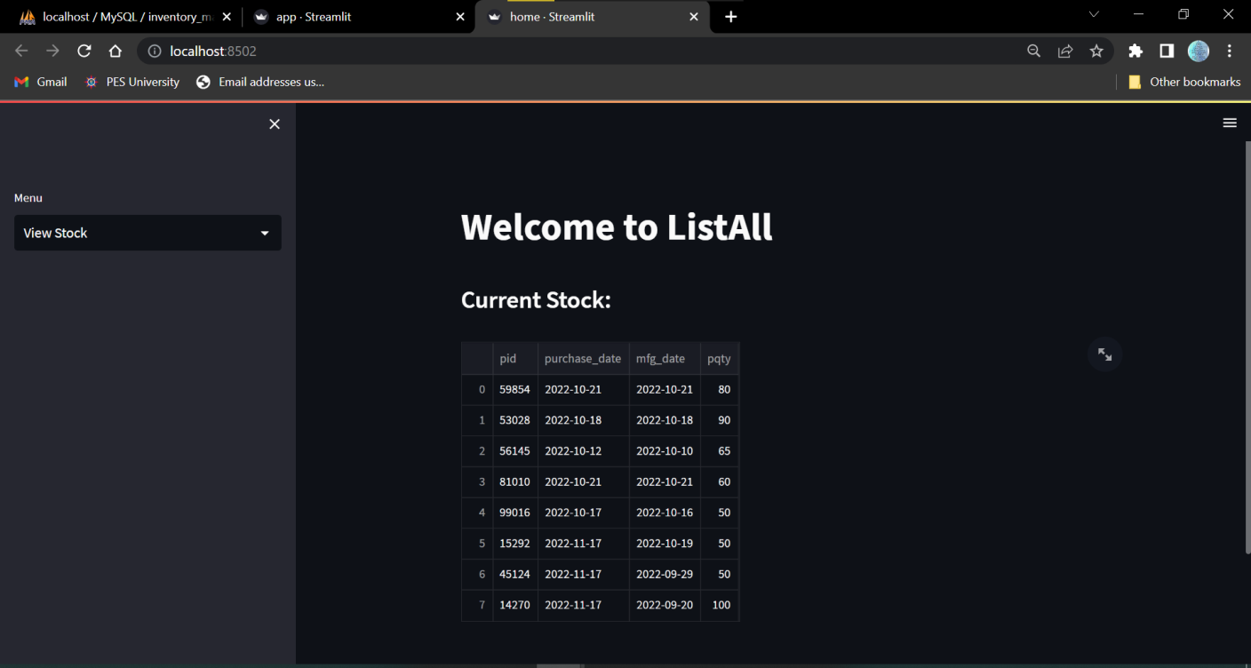

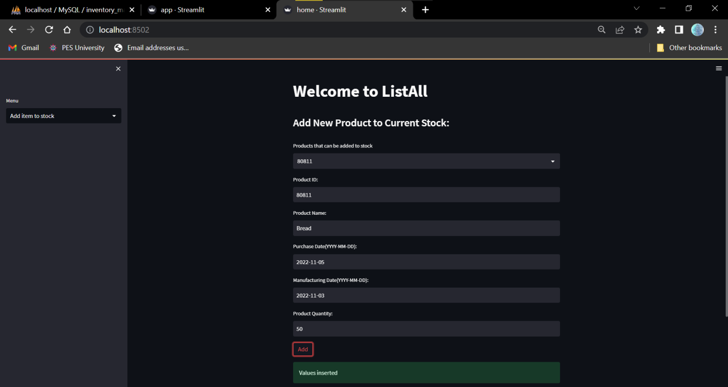

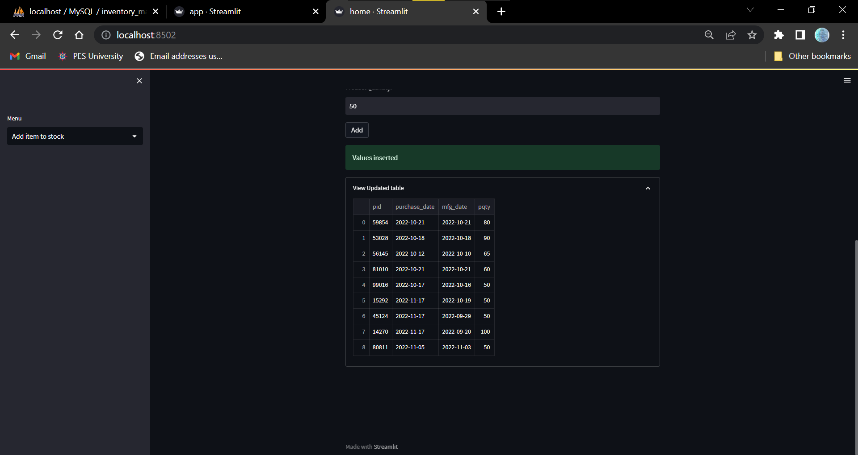

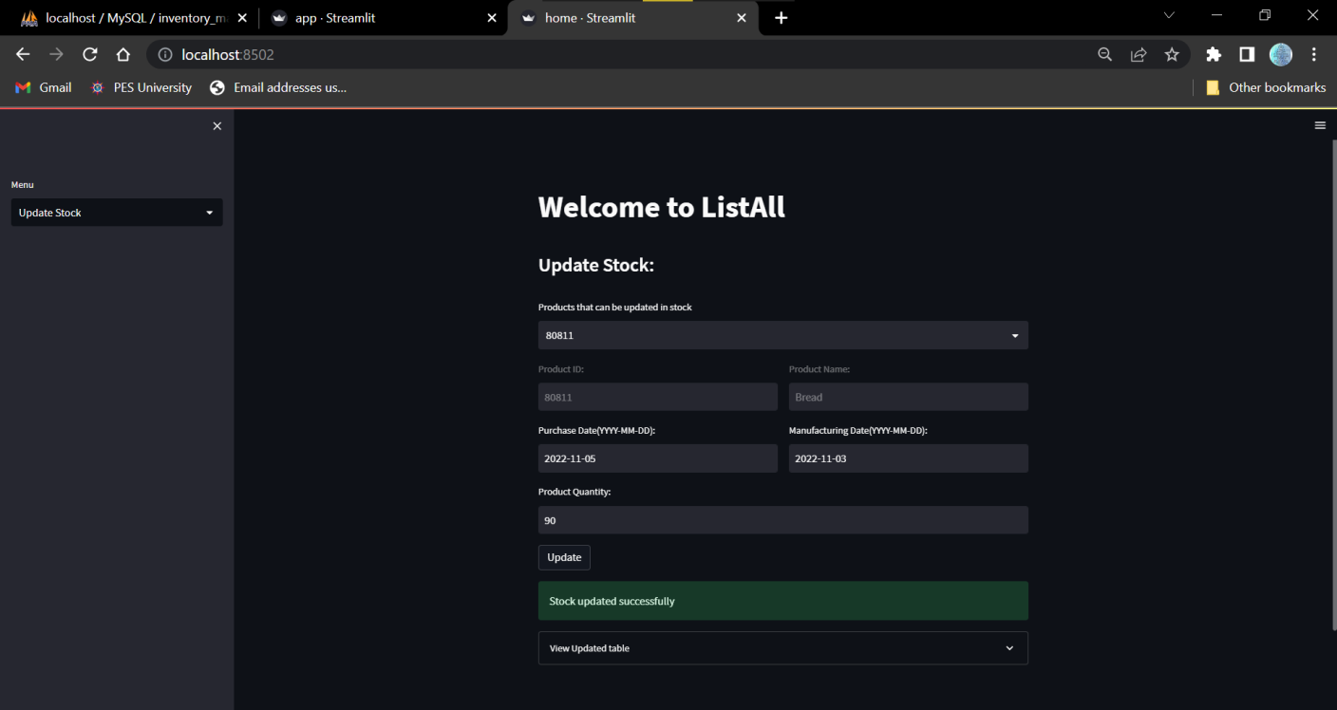

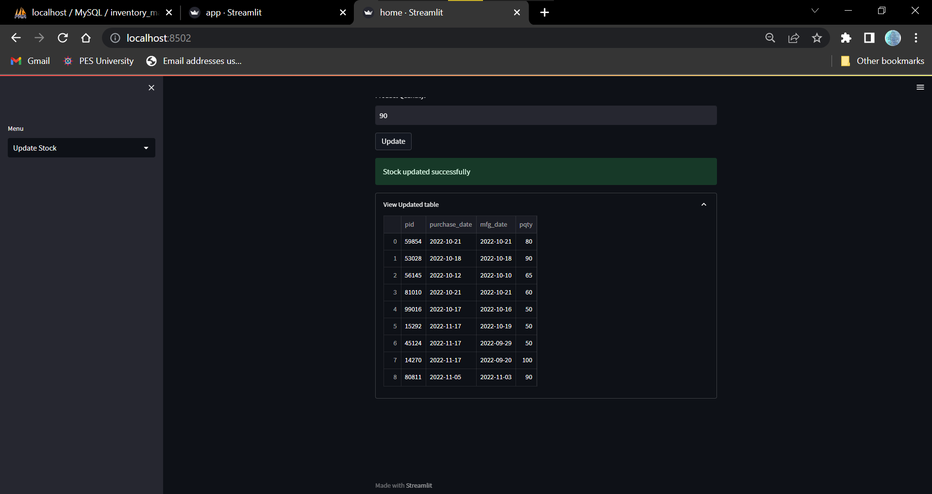

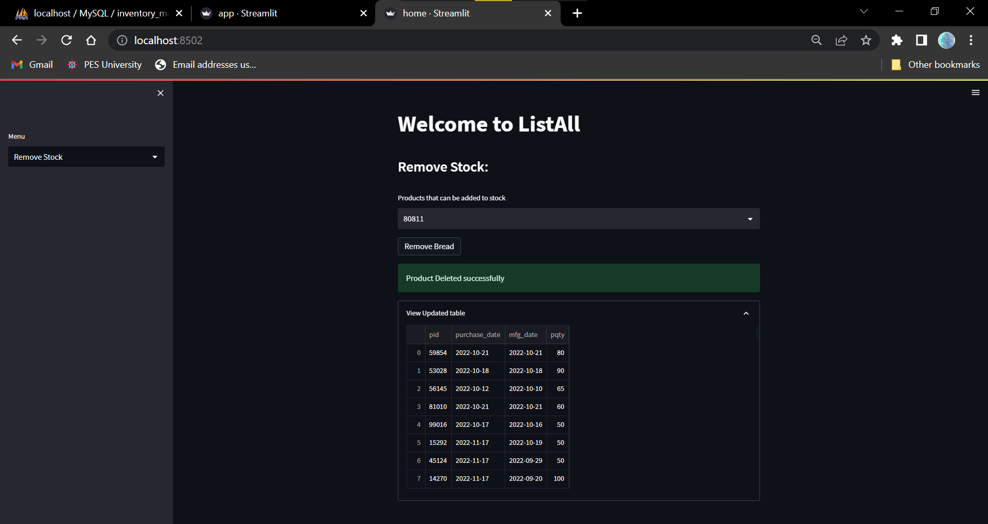

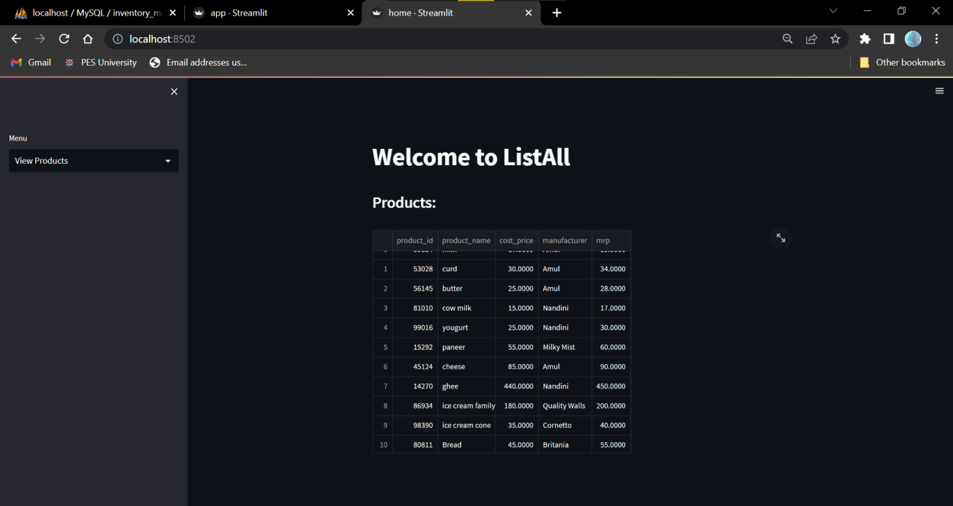

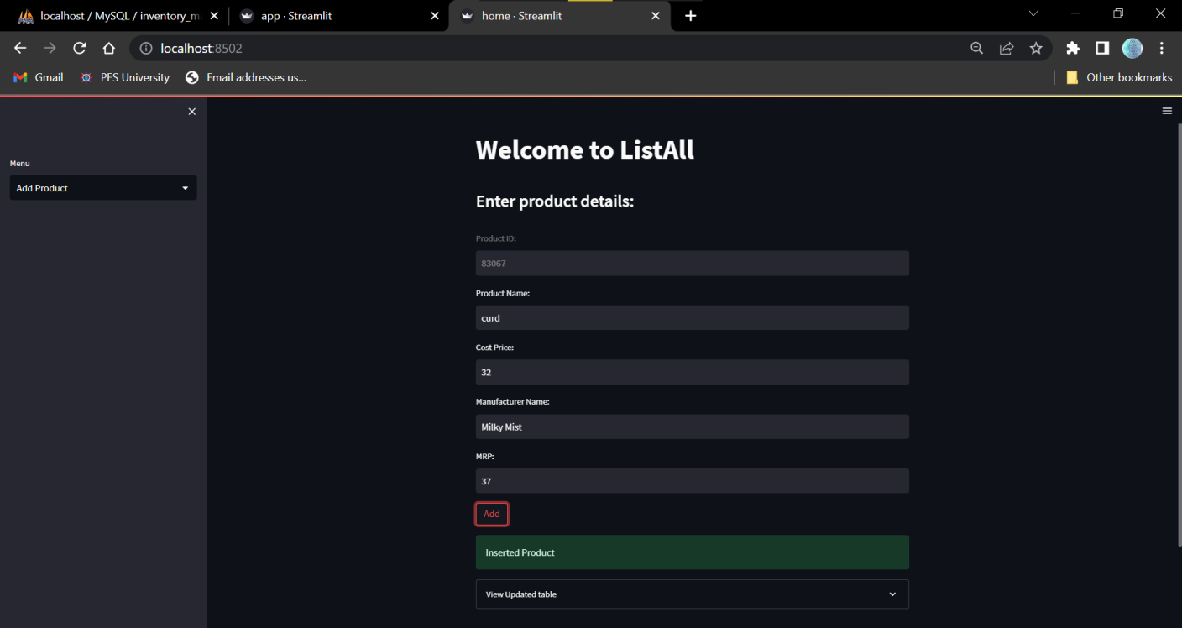

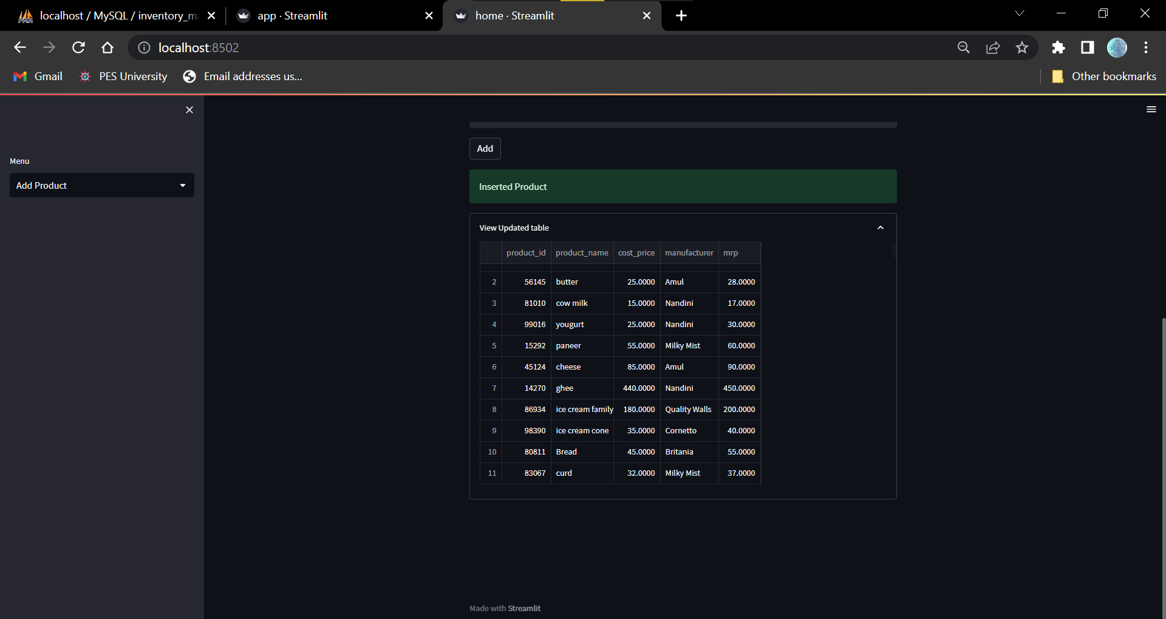

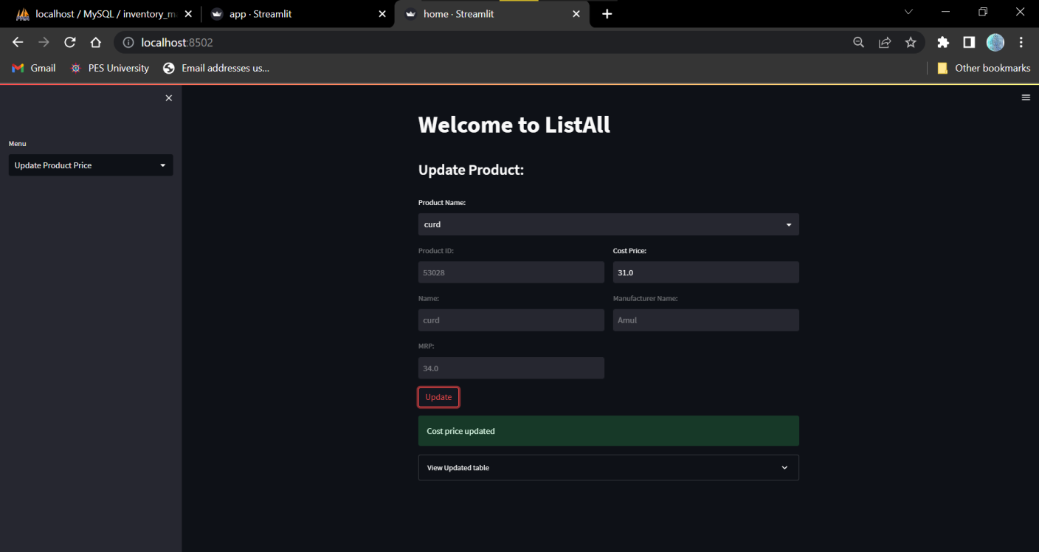

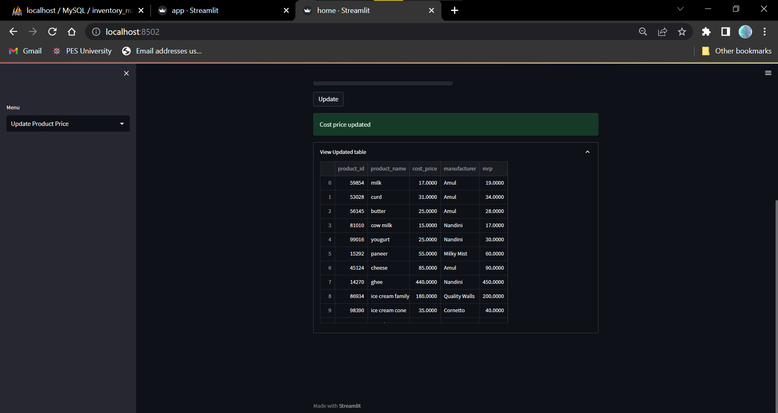

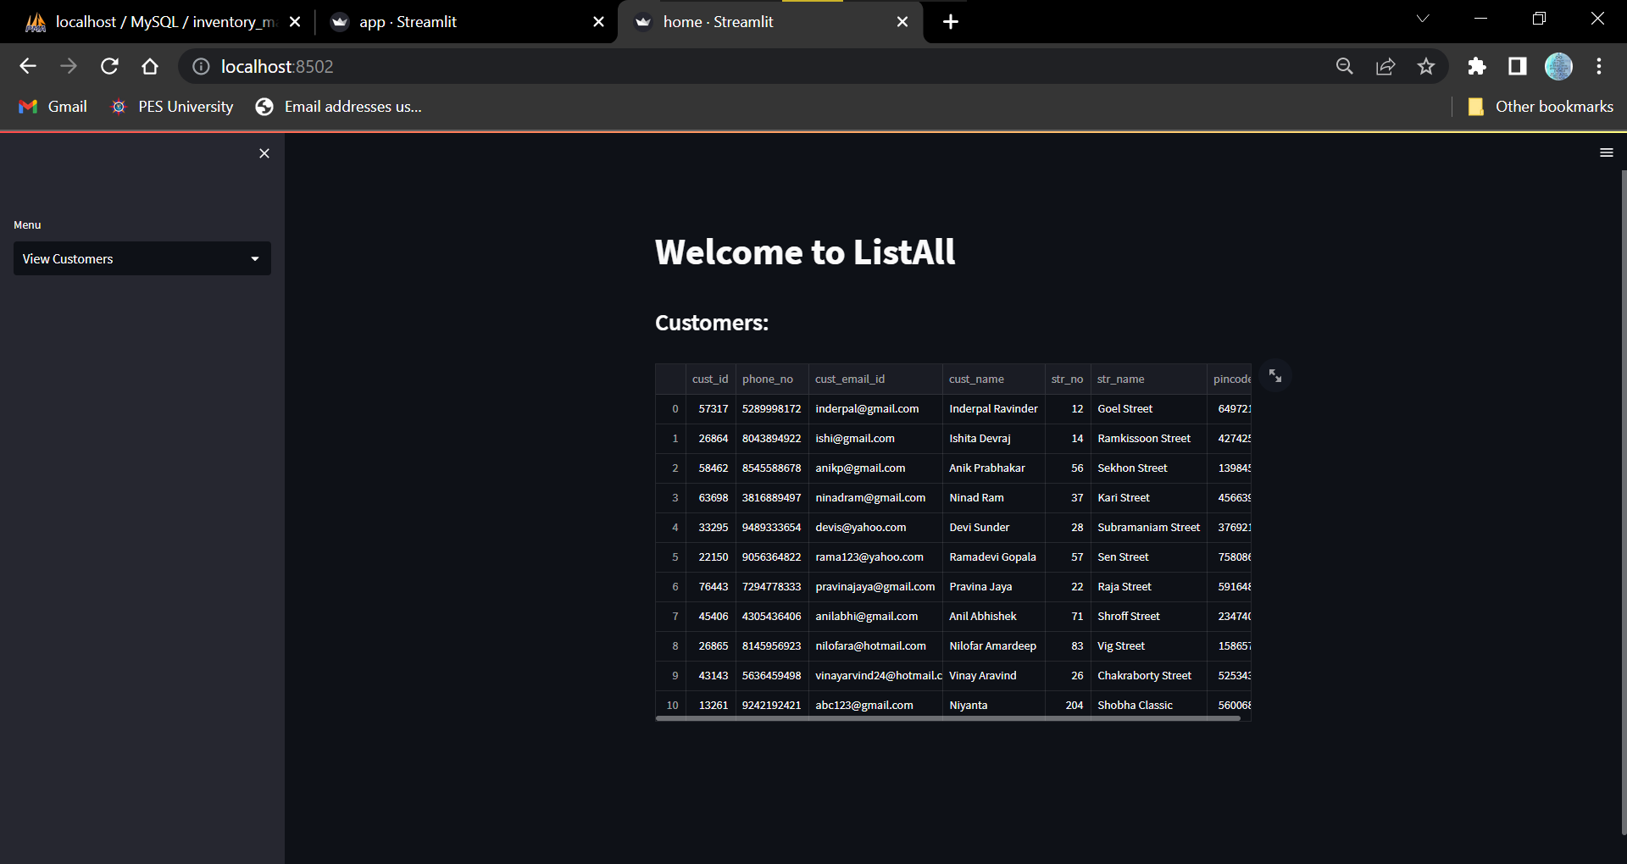

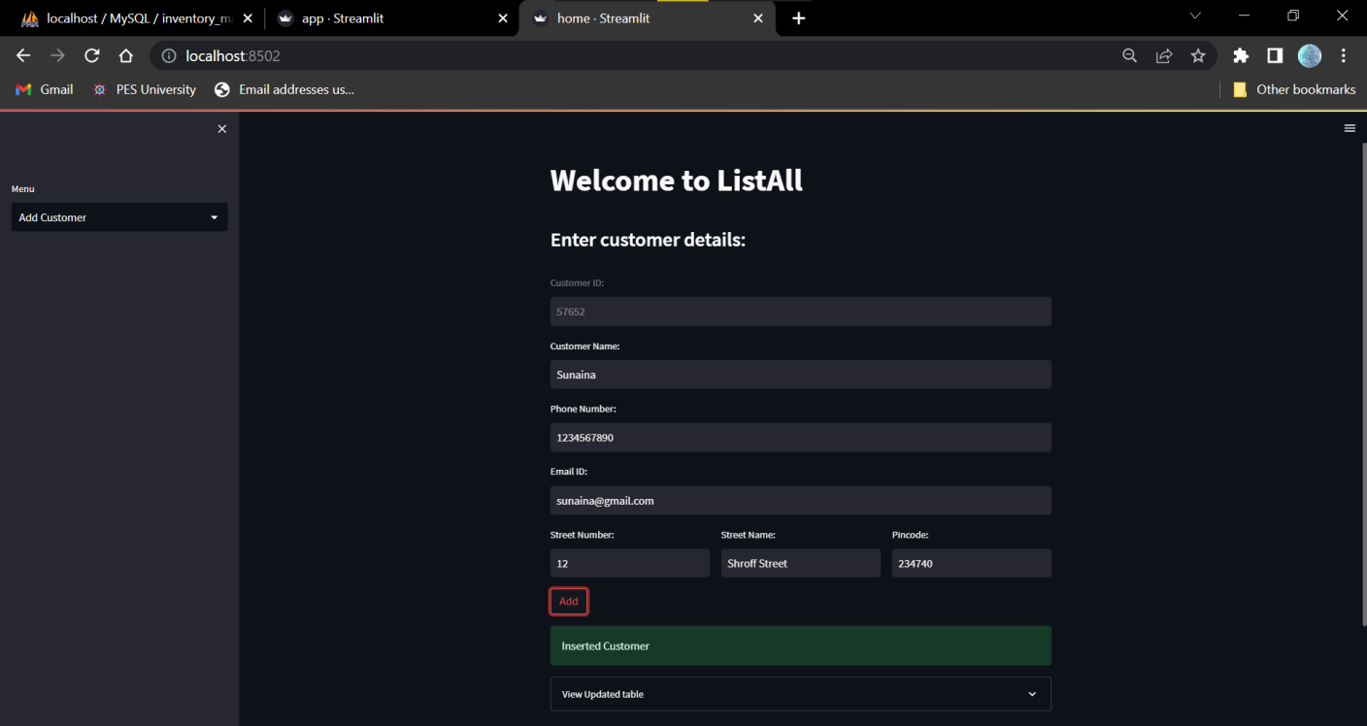

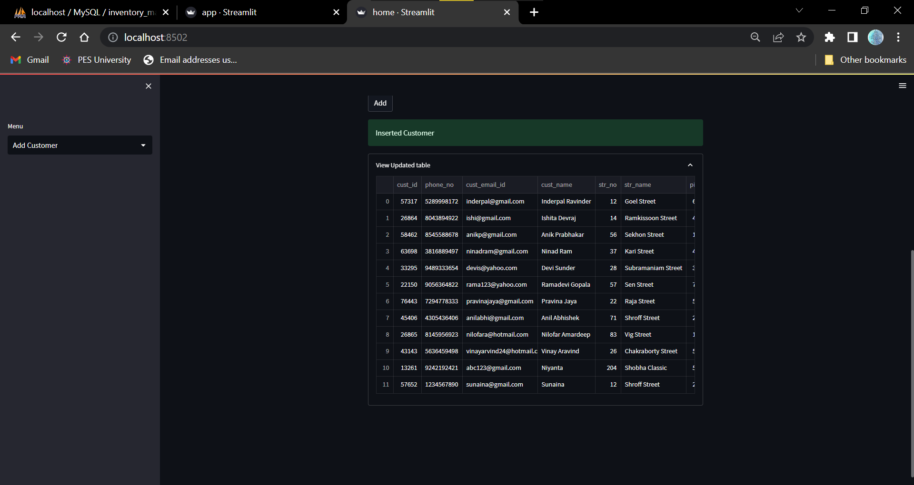

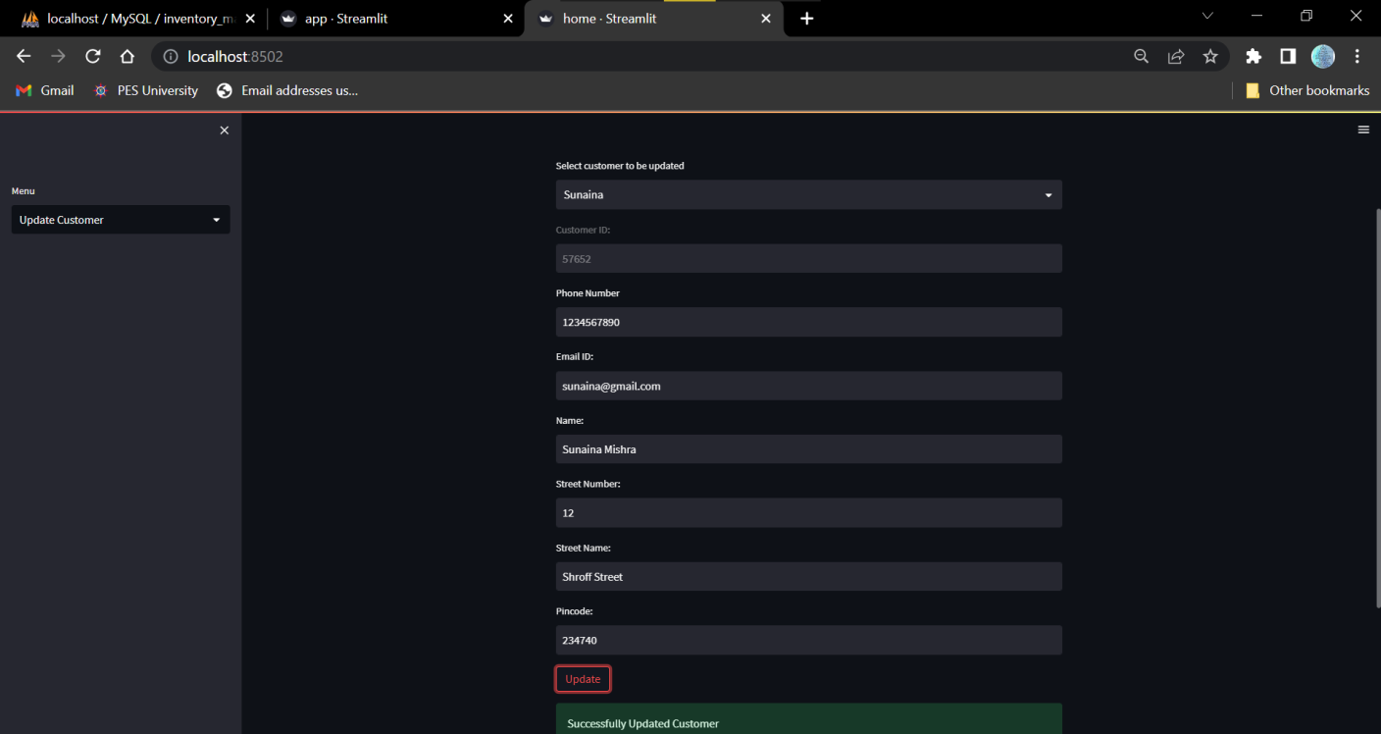

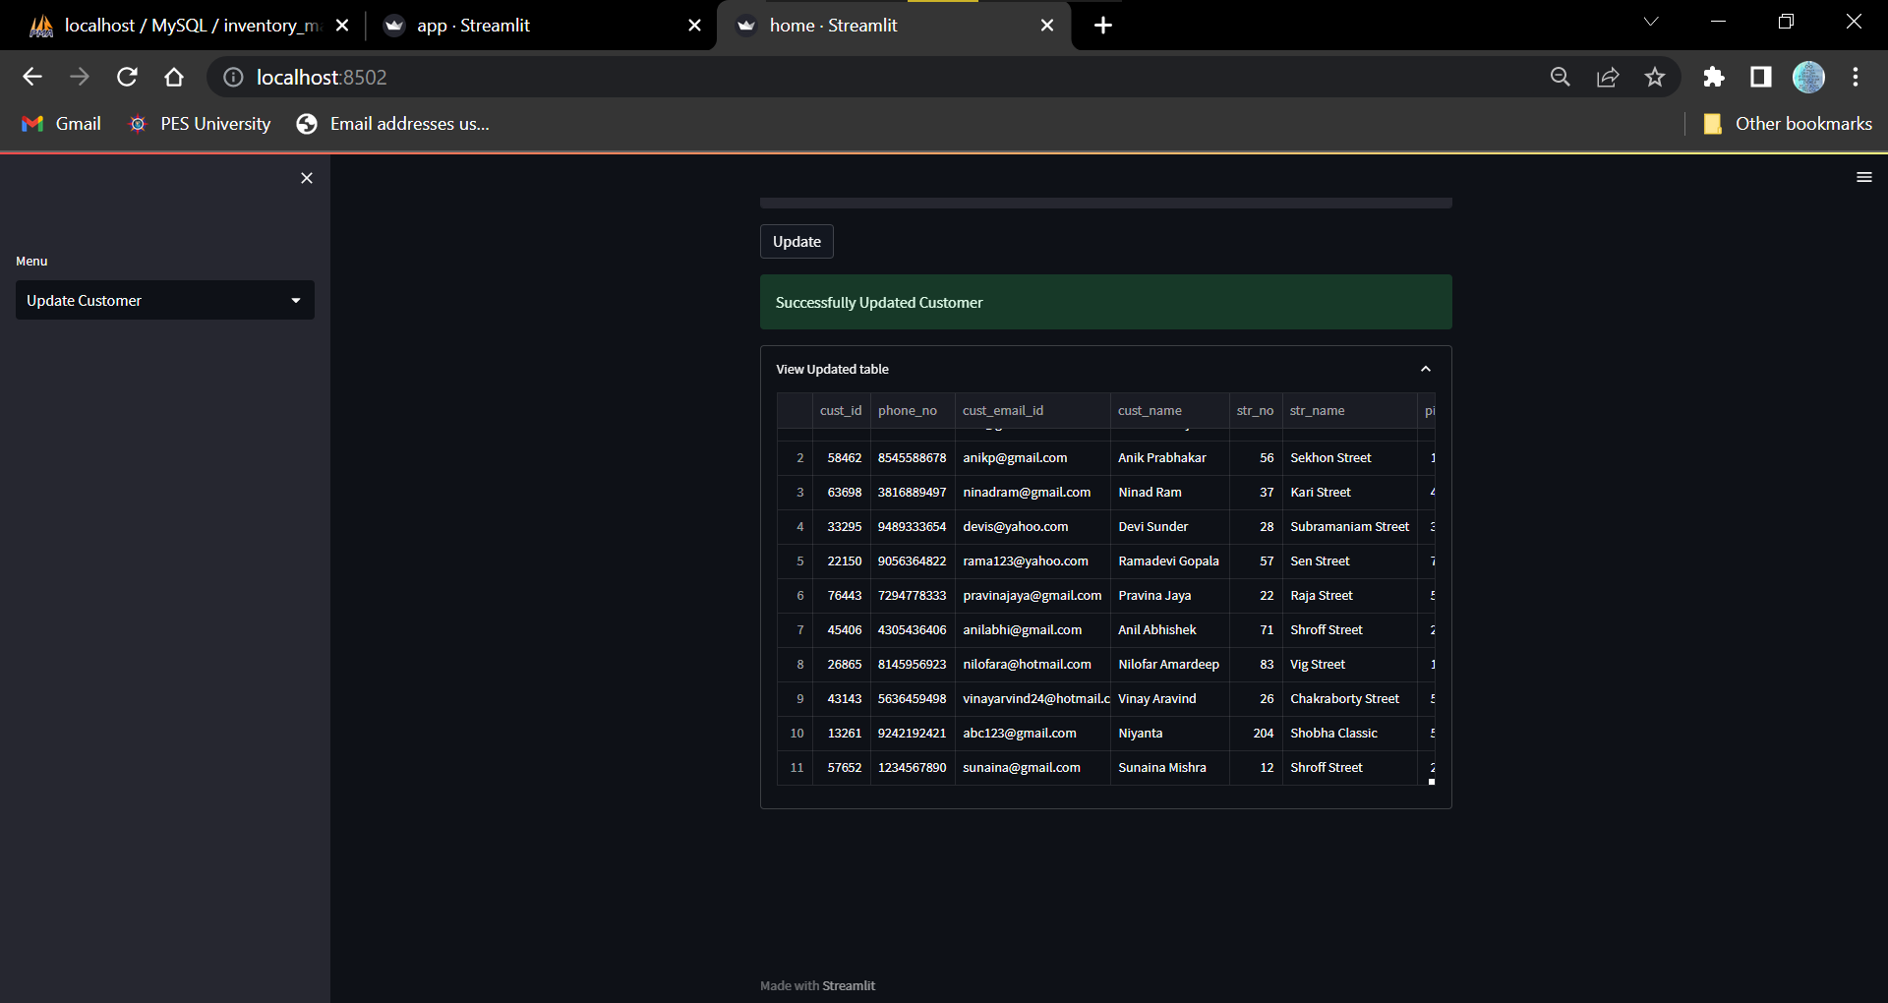

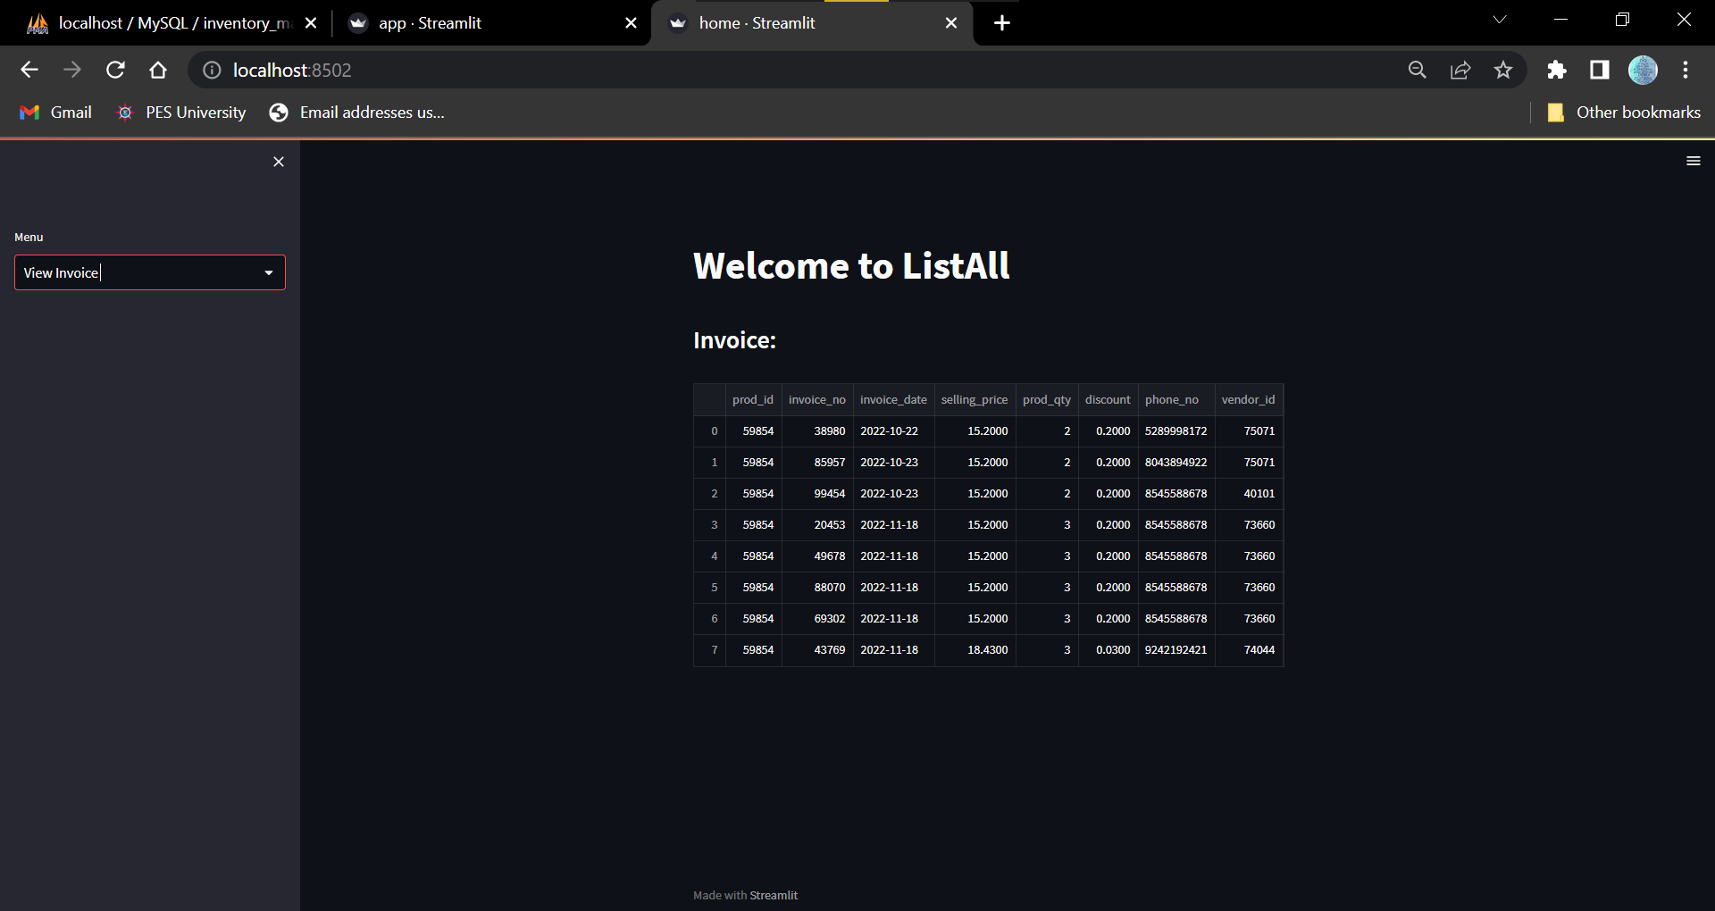

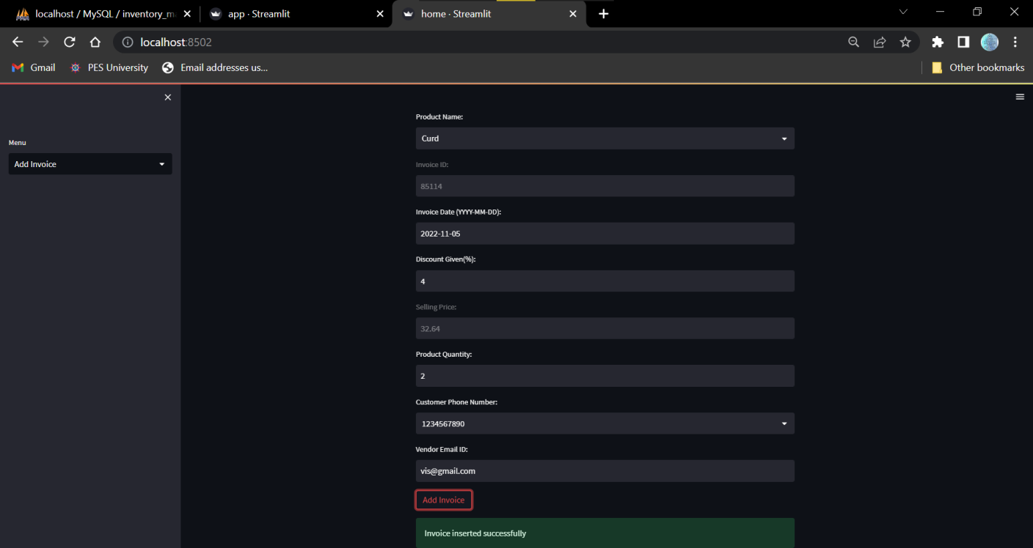

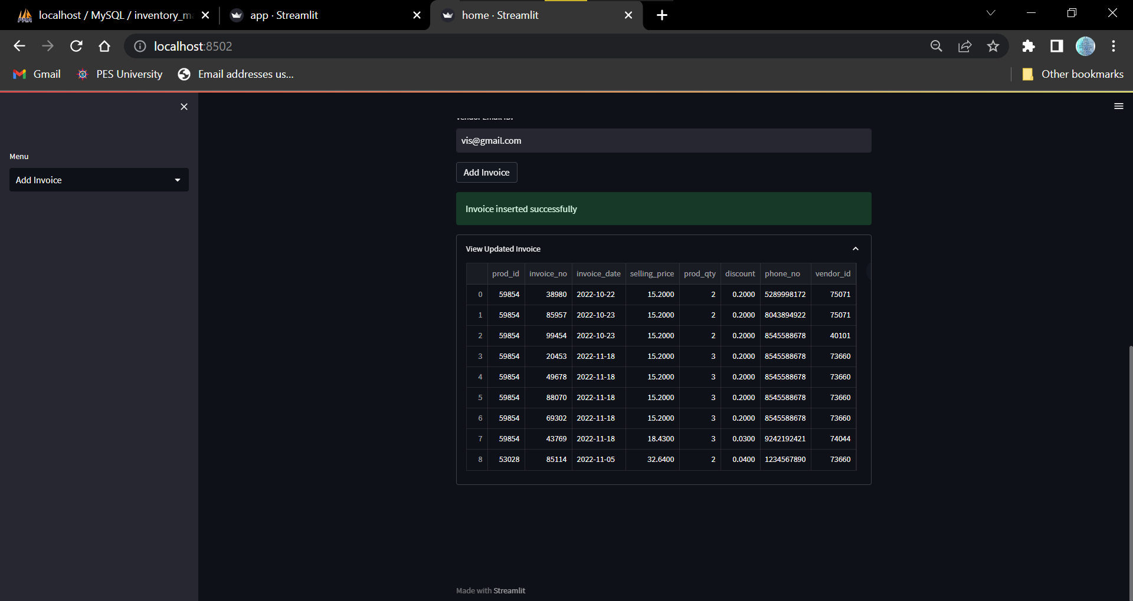

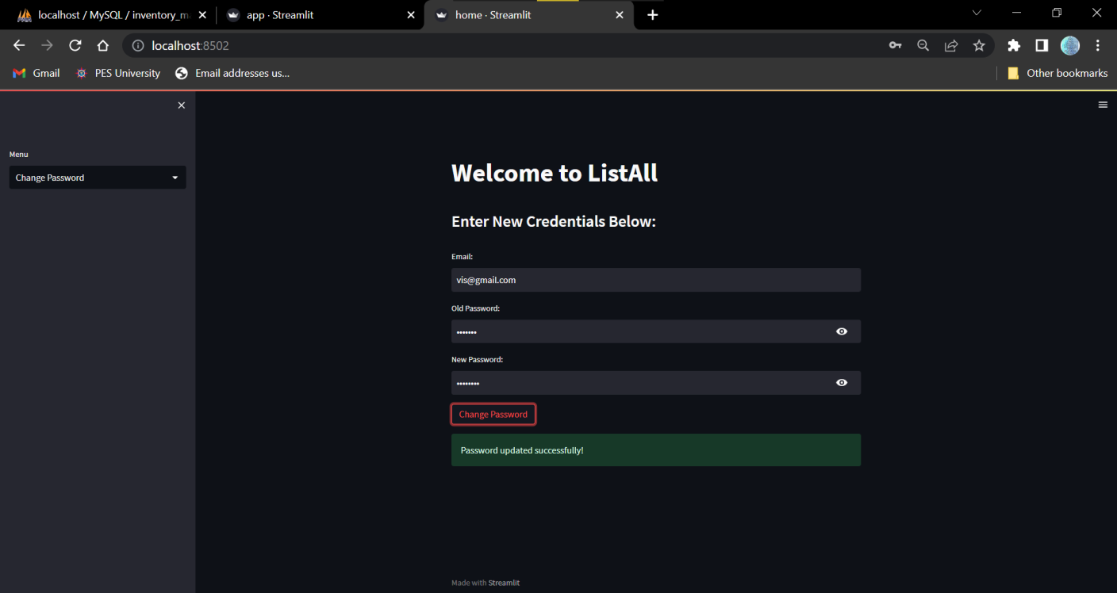

**12. Conclusion**

The project currently performs most basic CRUD operations on the database and comprises of triggers, functions, procedures, cursors etc. to help refine these CRUD operations. There is much more scope to this project and I will continue to build it going forward.

**13. References**

[1] PESU Academy Slides and Notes

[2] MySQL official documentation